**First Page**

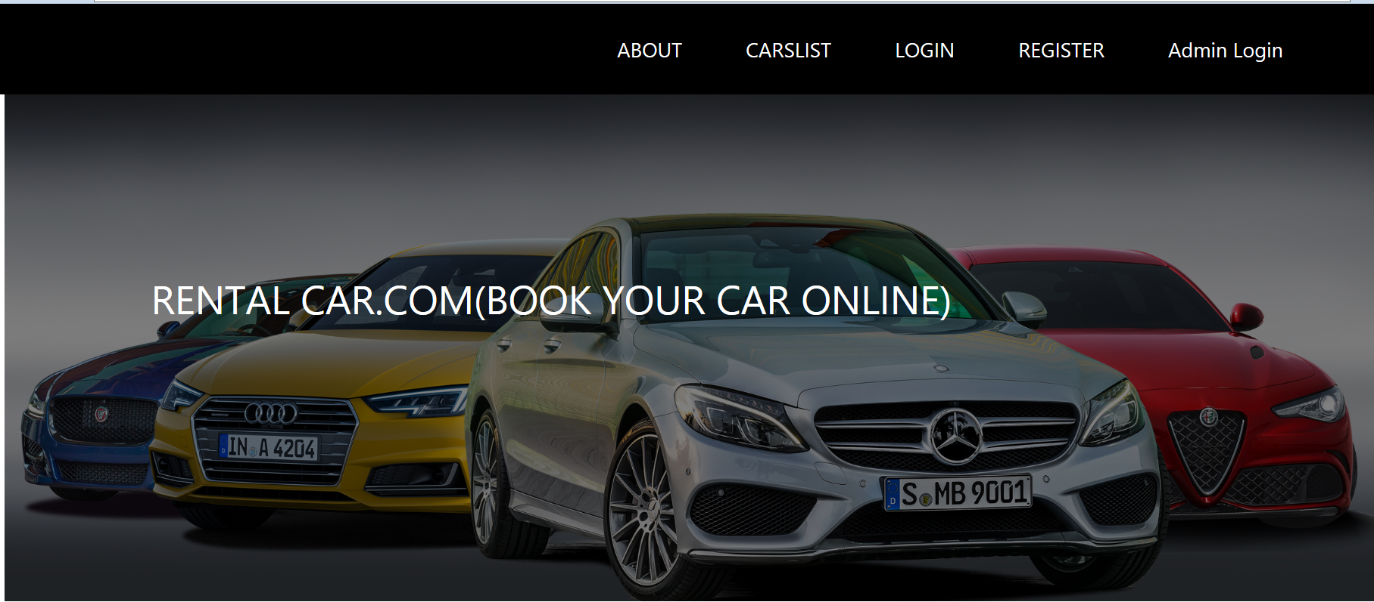

Code:

<!DOCTYPE html><html><head><meta charset=*"ISO-8859-1"*>

<title>firstpage</title>

<link rel=*"stylesheet"* type=*"text/css"* href=*"firstpage.css"*>

<link href=*"https://stackpath.bootstrapcdn.com/bootstrap/4.1.3/css/bootstrap.min.css"* rel=*"stylesheet"*>

</head>

<body><header>

<nav class=*"navbar navbar-expand-lg navbar-ligh t fixed-top"*>

<div class=*"container"*>

<div class=*"collapse navbar-collapse"* id=*"navbarSupportedContent"*>

<ul class=*"navbar-nav ml-auto"*>

<li class=*"nav-item"*><a class=*"nav-link"* href=*"about.jsp"*>ABOUT</a></li>

<li class=*"nav-item"*><a class=*"nav-link"* href=*"firstcar.jsp"*>CARSLIST</a></li>

<li class=*"nav-item"*><a class=*"nav-link"* href=*"finallogin.jsp"*>LOGIN</a></li>

<li class=*"nav-item"*><a class=*"nav-link"* href=*"registration.jsp"*>REGISTER</a></li>

<li class=*"nav-item"*><a class=*"nav-link"* href=*"adminlogin.jsp"*>Admin Login</a></li>

</ul>

</div></div></nav>

<div class=*"title"*>

<h1>RENTAL CAR.COM(BOOK YOUR CAR ONLINE)</h1>

</div>

</header></body></html>

**Login Page**

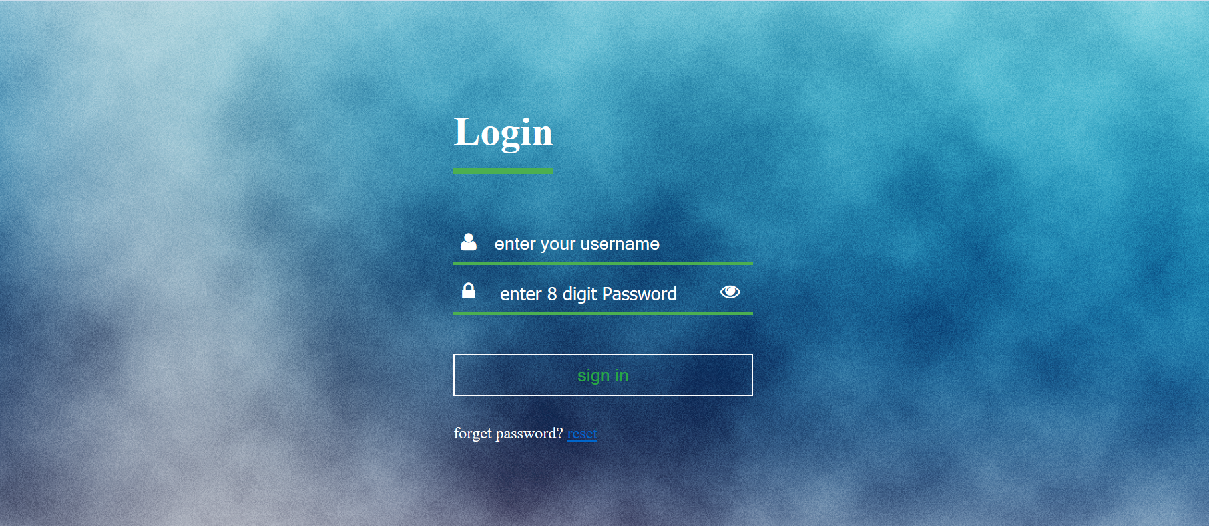

Code:

<!DOCTYPE html><html><head><meta charset=*"ISO-8859-1"*>

<title>final login</title>

<link rel=*"stylesheet"* type=*"text/css"* href=*"finallogin.css"*>

<script>

**function** Toggle() {

**var** temp = document.getElementById("pass");

**if** (temp.type === "password") {

temp.type = "text";

}

**else** {

temp.type = "password";

}

} </script></head>

<body><div class=*"reg"*><br>

<form id=*"reg"* method=*"post"* name=*"frm"* action=*"./login"*>

<div class=*"login-box"*>

<h1>Login</h1>

<div class=*"textbox"*>

<i class=*"fa fa-user"* aria-hidden=*"true"*></i>

<input type=*"text"* placeholder=*"enter your username"* name=*"uname"* value=*""*required=*"required"*>

</div>

<div class=*"textbox"*>

<i class=*"fa fa-lock"* aria-hidden=*"true"*></i>

<input type=*"Password"* placeholder=*" enter 8 digit Password"* maxlength=*"8"* name=*"pass"* id=*"pass"* value=*""* required=*"required"*>

<span><i class=*"fa fa-eye"* aria-hidden=*"true"* onclick="Toggle()"></i></span>

</div><br>

<input type=*"submit"* class=*"btn"* name=*"button"* value=*"sign in"*>

<p class=*"message"*>forget password? <a href=*"reset.jsp"*>reset</a></p></div></form></div></body></html>

**Registration Page**

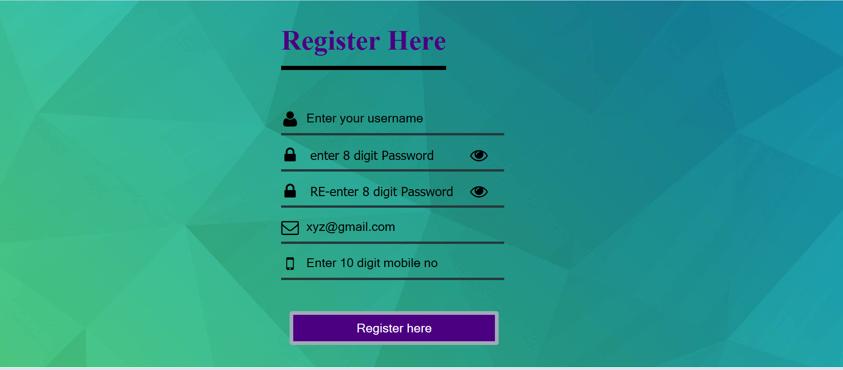

Code

<!DOCTYPE html><html><head><meta charset=*"ISO-8859-1"*>

<title>register</title>

<link rel=*"stylesheet"* type=*"text/css"* href=*"registration.css"*>

<script>

**function** validate(form){

**var** pass=frm.t2.value;

**var** pass2=frm.t3.value;

**var** mobile=frm.t5.value;

**if**(mobile.length<10){

alert("Your number must be atleast\n10 digits long.\n Please try again.");

frm.t5.focus();

}

**if**(pass.length<8){

alert("Your password must be atleast\n8 characters long.\n Please try again.");

frm.t2.value="";

frm.t3.value="";

frm.t2.focus();

}

**if**(frm.t2.value !=frm.t3.value){

alert("Your password entries didnot match.\n Please try again.");

frm.t2.value="";

frm.t3.value="";

frm.t2.focus();

}}

**function** check(){

alert("password should contain uppercase and lower case letters, number,symbols"); }

**function** Toggle() {

**var** temp = document.getElementById("pass");

**if** (temp.type === "password") {

temp.type = "text";

}

**else** {

temp.type = "password";

} }

**function** Togg() {

**var** temp = document.getElementById("conpass");

**if** (temp.type === "password") {

temp.type = "text";

}

**else** {

temp.type = "password";

} }

</script></head>

<body><div class=*"reg"*>

<form id=*"reg"* method=*"post"* action=*"./register"* name=*"frm"* onsubmit="validate(this)">

<div class=*"login-box"*>

<h1>Register Here</h1>

&nbsp;&nbsp;&nbsp;&nbsp;&nbsp;&nbsp;&nbsp;

<div class=*"textbox"*>

<i class=*"fa fa-user"* aria-hidden=*"true"*></i>

<input type=*"text"* placeholder=*"Enter your username"* id=*"user"* name=*"t1"* value=*""*required=*"required"*>

</div>

<div class=*"textbox"*>

<i class=*"fa fa-lock"* aria-hidden=*"true"*></i>

<input type=*"Password"* placeholder=*" enter 8 digit Password"* maxlength=*"8"* name=*"t2"* id=*"pass"* value=*""* required=*"required"*>

<span><i class=*"fa fa-eye"* aria-hidden=*"true"* onclick="Toggle()"></i></span>

</div>

<div class=*"textbox"*>

<i class=*"fa fa-lock"* aria-hidden=*"true"*></i>

<input type=*"Password"* placeholder=*" RE-enter 8 digit Password"* maxlength=*"8"* name=*"t3"* id=*"conpass"* value=*""* required=*"required"*>

<span><i class=*"fa fa-eye"* aria-hidden=*"true"* onclick="Togg()"></i></span>

</div>

<div class=*"textbox"*>

<i class=*"fa fa-envelope-o"* aria-hidden=*"true"*></i>

<input type=*"email"* name=*"t4"* value=*"xyz@gmail.com"*placeholder=*"abc@gmail.com"* id=*"name"*required=*"required"*>

</div>

<div class=*"textbox"*>

<i class=*"fa fa-mobile"* aria-hidden=*"true"*></i>

<input type=*"text"* name=*"t5"* placeholder=*"Enter 10 digit mobile no"* id=*"name"* maxlength=*"10"* required=*"required"*>

</div><br><br>

&nbsp;&nbsp;&nbsp;<button type=*"submit"* id=*"sub"* onclick="validate(form);">Register here</button><br><br><br>

</div></form></div></body></html>

**HomePage**

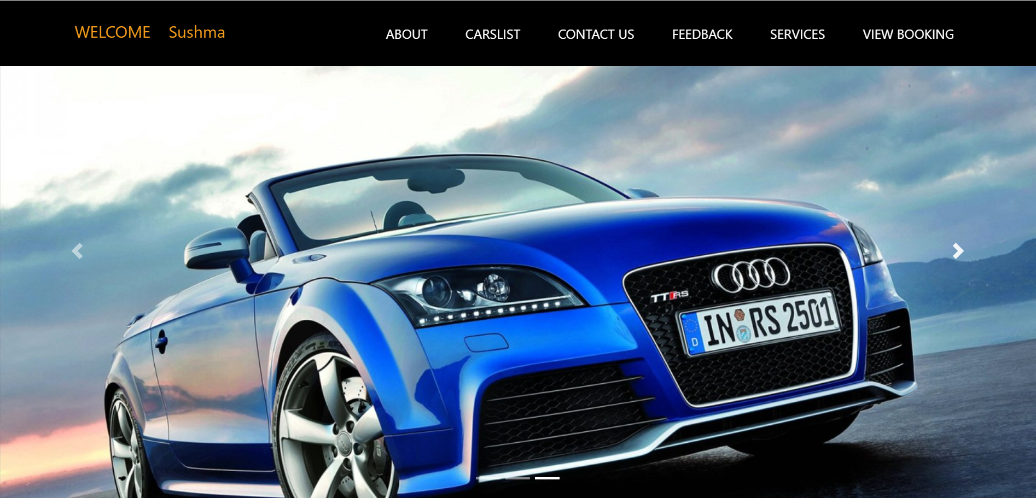

Code

<%@ page language=*"java"* contentType=*"text/html; charset=ISO-8859-1"*pageEncoding=*"ISO-8859-1"*%>

<!DOCTYPE html><html lang=*"en"*><head><meta charset=*"UTF-8"*>

<title>Homepage with navbar and slider</title>

<link href=*"https://stackpath.bootstrapcdn.com/bootstrap/4.1.3/css/bootstrap.min.css"* rel=*"stylesheet"*>

<link href=*"homepage.css"* rel=*"stylesheet"*></head>

<body><header>

<nav class=*"navbar navbar-expand-lg navbar-light fixed-top"*>

<div class=*"container"*>

<p class=*"navbar-brand"*>WELCOME &nbsp;&nbsp;&nbsp;<%=session.getAttribute("uname") %></p>

<div class=*"collapse navbar-collapse"* id=*"navbarSupportedContent"*>

<ul class=*"navbar-nav ml-auto"*>

<li class=*"nav-item"*><a class=*"nav-link"* href=*"homepage.jsp"* id=*"active"*>HOME</a></li>

<li class=*"nav-item"*><a class=*"nav-link"* href=*"about.jsp"*>ABOUT</a></li>

<li class=*"nav-item"*><a class=*"nav-link"* href=*"carslist.jsp"*>CARSLIST</a></li>

<li class=*"nav-item"*><a class=*"nav-link"* href=*"contact.jsp"*>CONTACT US</a></li>

<li class=*"nav-item"*><a class=*"nav-link"* href=*"feedback.jsp"*>FEEDBACK</a></li>

<li class=*"nav-item"*><a class=*"nav-link"* href=*"service.jsp"*>SERVICES</a></li>

<li class=*"nav-item"*><a class=*"nav-link"* href=*"search.jsp"* >VIEW BOOKING</a></li>

</ul></div></div></nav>

<div class=*"carousel slide"* data-ride=*"carousel"* id=*"carouselExampleIndicators"*>

<ol class=*"carousel-indicators"*>

<li class=*"active"* data-slide-to=*"0"* data-target=*"#carouselExampleIndicators"*></li>

<li data-slide-to=*"1"* data-target=*"#carouselExampleIndicators"*></li>

<li data-slide-to=*"2"* data-target=*"#carouselExampleIndicators"*></li></ol>

<div class=*"carousel-inner"*>

<div class=*"carousel-item active"*>

<video autoplay muted loop> <source src=*"video\Mercedes Cars Road Trip.mp4"*

class=*"d-block w-100"* type=*"video/mp4"* ></video></div>

<div class=*"carousel-item "*>

<img alt=*"First slide"* class=*"d-block w-100"* src=*"images/slider1.jpg"*>

<div class=*"carousel-caption d-none d-md-block"*></div></div>

<div class=*"carousel-item"*>

<img alt=*"Second slide"* class=*"d-block w-100"* src=*"images/slider2.jpg"*>

<div class=*"carousel-caption d-none d-md-block"*></div></div>

<div class=*"carousel-item"*>

<img alt=*"Third slide"* class=*"d-block w-100"* src=*"images/slider5.jpg"*>

<div class=*"carousel-caption d-none d-md-block"*></div></div></div>

<a class=*"carousel-control-prev"* data-slide=*"prev"* href=*"#carouselExampleIndicators"* role=*"button"*>

<span aria-hidden=*"true"* class=*"carousel-control-prev-icon"*></span>

<span class=*"sr-only"*>Previous</span></a <a class=*"carousel-control-next"* data-slide=*"next"* href=*"#carouselExampleIndicators"* role=*"button"*> <span aria-hidden=*"true"* class=*"carousel-control-next-icon"*></span> <span class=*"sr-only"*>Next</span></a></div>

<script src=*"https://code.jquery.com/jquery-3.3.1.slim.min.js"*></script>

<script src=*"https://cdnjs.cloudflare.com/ajax/libs/popper.js/1.14.3/umd/popper.min.js"*></script>

<script src=*"https://stackpath.bootstrapcdn.com/bootstrap/4.1.3/js/bootstrap.min.js"*></script>

</header></body></html>

**About Page**

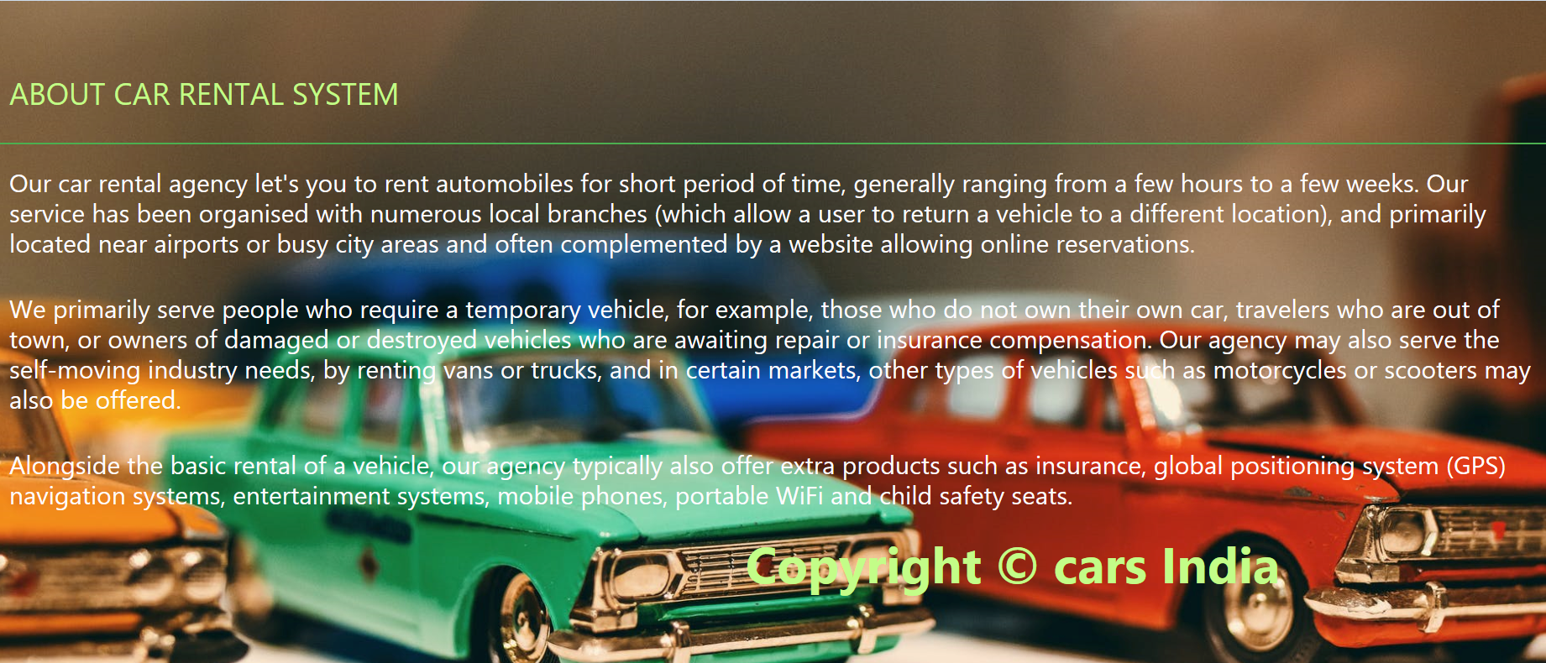

Code

<!DOCTYPE html>

<html><head><meta charset=*"ISO-8859-1"*>

<title>about page</title>

<link rel=*"stylesheet"* type=*"text/css"* href=*"about.css"*>

<link href=*"https://stackpath.bootstrapcdn.com/bootstrap/4.1.3/css/bootstrap.min.css"* rel=*"stylesheet"*>

</head>

<body><br><br>

<div class=*"content"*><div class=*"about"*>

<h4><p>ABOUT CAR RENTAL SYSTEM</p></h4>

<h5>Our car rental agency let's you to rent automobiles for short period of time, generally ranging from a few hours to a few weeks. Our service has been organised with numerous local branches (which allow a user to return a vehicle to a different location), and primarily located near airports or busy city areas and often complemented by a website allowing online reservations.</h5>

<h5>We primarily serve people who require a temporary vehicle, for example, those who do not own their own car, travelers who are out of town, or owners of damaged or destroyed vehicles who are awaiting repair or insurance compensation. Our agency may also serve the self-moving industry needs, by renting vans or trucks, and in certain markets, other types of vehicles such as motorcycles or scooters may also be offered.</h5>

<h5> Alongside the basic rental of a vehicle, our agency typically also offer extra products such as insurance, global positioning system (GPS) navigation systems, entertainment systems, mobile phones, portable WiFi and child safety seats. </h5>

</div><br>

<div>

<p class=*"footer"*><font color=*"#FEFCFF"*><b class=*"foot"*>Copyright &copy; cars India</b></font></p>

</div></div></body></html>

**Carslist Page with description**

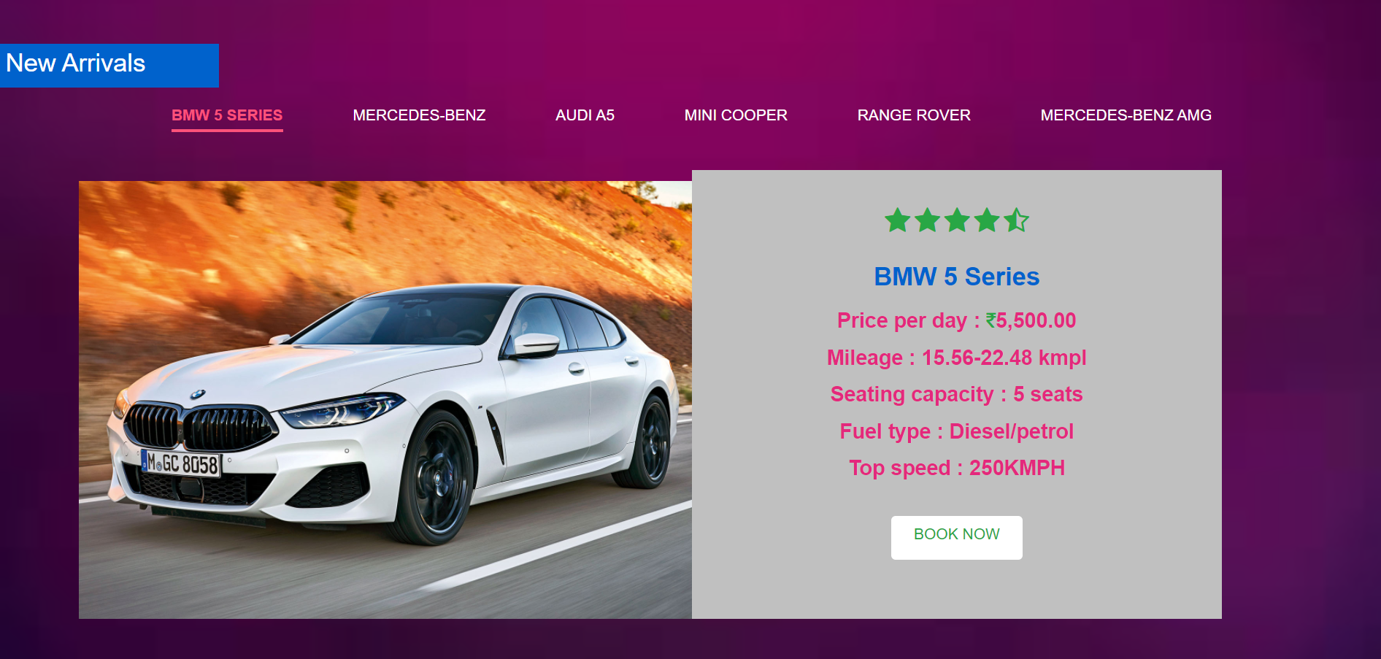

Code:

<!DOCTYPE html><html><head><meta charset=*"ISO-8859-1"*>

<title>Insert title here</title>

<link href=*"https://fonts.googleapis.com/css2?family=Poppins&display=swap"* rel=*"stylesheet"*>

<link rel=*"stylesheet"* href=*"https://cdnjs.cloudflare.com/ajax/libs/font-awesome/4.7.0/css/font-awesome.min.css"*>

<link rel=*"stylesheet"* href=*"https://stackpath.bootstrapcdn.com/bootstrap/4.5.2/css/bootstrap.min.css"*>

<link rel=*"stylesheet"* href=*"https://stackpath.bootstrapcdn.com/font-awesome/4.7.0/css/font-awesome.min.css"*></head>

<div id=*"services-02"*> <div class=*"content-box-md"*> <div id=*"services-tabs"*>

<div class=*"containersd"*><h3>New Arrivals</h3></div>

<ul class=*"text-center"*>

<li><a href=*"#service-tab-1"* >BMW 5 Series</a></li>

<li><a href=*"#service-tab-2"*>MERCEDES-BENZ</a></li>

<li><a href=*"#service-tab-3"*>AUDI A5</a></li>

<li><a href=*"#service-tab-4"* >MINI COOPER</a></li>

<li><a href=*"#service-tab-5"*>RANGE ROVER</a></li>

<li><a href=*"#service-tab-6"*>MERCEDES-BENZ AMG</a></li>

</ul>

<br>

<!-- Service Tab 01 -->

<div id=*"service-tab-1"* class=*"service-tab"*><div class=*"container"*>

<div class=*"row wow fadeInUp"* data-wow-duration=*"0.5s"* data-wow-delay=*"0.5s"*>

<div class=*"col-md-6"*> <img src=*"images/bmw.jpg"* alt=*"creativity"*></div>

<div class=*"col-md-6"*>

<div class=*"tab-bg"*>

<div class=*"product-bottom text-center"*><br>

<i class=*"fa fa-star"* aria-hidden=*"true"*></i>

<i class=*"fa fa-star"* aria-hidden=*"true"*></i>

<i class=*"fa fa-star"* aria-hidden=*"true"*></i>

<i class=*"fa fa-star"* aria-hidden=*"true"*></i>

<i class=*"fa fa-star-half-o"* aria-hidden=*"true"*></i>

<div class=*"desc"*><h4 >BMW 5 Series</h4>

<h6> Price per day : <i class=*"fa fa-rupee"* style="font-size:*17px*"></i>5,500.00</h6>

<h6> Mileage : 15.56-22.48 kmpl</h6>

<h6>Seating capacity : 5 seats</h6>

<h6> Fuel type : Diesel/petrol</h6>

<h6> Top speed : 250KMPH</h6><br>

<a id=*"services-"* class=*"btn btn-general btn-yellow"* href=*"bmw table.jsp"* role=*"button"*>Book Now</a>

</div> </div></div></div></div></div></div>

<!-- Service Tab 02 -->

<div id=*"service-tab-2"* class=*"service-tab"*>

<div class=*"container"*>

<div class=*"row wow fadeInUp"* data-wow-duration=*"0.5s"* data-wow-delay=*"0.5s"*>

<div class=*"col-md-6"*>

<img src=*"images/begh.jpg"* alt=*"creativity"*>

</div>

<div class=*"col-md-6"*>

<div class=*"tab-bg"*>

<div class=*"product-bottom text-center"*><br>

<i class=*"fa fa-star"* aria-hidden=*"true"*></i>

<i class=*"fa fa-star"* aria-hidden=*"true"*></i>

<i class=*"fa fa-star"* aria-hidden=*"true"*></i>

<i class=*"fa fa-star"* aria-hidden=*"true"*></i>

<i class=*"fa fa-star-half-o"* aria-hidden=*"true"*></i>

<div class=*"desc"*><h4 >MERCEDES-BENZ</h4>

<h6>Price per day :<i class=*"fa fa-rupee"* style="font-size:*17px*"></i> 6,200.00</h6>

<h6>Mileage : 17.56-25.48 kmpl</h6>

<h6>Seating capacity : 4 seats</h6>

<h6>Fuel type : Diesel/petrol</h6>

<h6>Top speed : 220KMPH</h6><br>

<a id=*"services-"* class=*"btn btn-general btn-yellow"* href=*"benz table.jsp"* role=*"button"*>Book Now</a>

</div> </div> </div></div></div></div></div>

<!-- Service Tab 03 -->

<div id=*"service-tab-3"* class=*"service-tab"*>

<div class=*"container"*>

<div class=*"row wow fadeInUp"* data-wow-duration=*"0.5s"* data-wow-delay=*"0.5s"*>

<div class=*"col-md-6"*> <img src=*"images/audi.jpg"* alt=*"creativity"*></div>

<div class=*"col-md-6"*>

<div class=*"tab-bg"*>

<div class=*"product-bottom text-center"*><br>

<i class=*"fa fa-star"* aria-hidden=*"true"*></i>

<i class=*"fa fa-star"* aria-hidden=*"true"*></i>

<i class=*"fa fa-star"* aria-hidden=*"true"*></i>

<i class=*"fa fa-star"* aria-hidden=*"true"*></i>

<i class=*"fa fa-star-half-o"* aria-hidden=*"true"*></i>

<div class=*"desc"*><h4 >AUDI A5</h4>

<h6>Price per day :<i class=*"fa fa-rupee"* style="font-size:*17px*"></i> 6,000.00</h6>

<h6>Mileage : 16.76-23.50 kmpl</h6>

<h6>Seating capacity : 4 seats</h6>

<h6>Fuel type : Diesel/petrol</h6>

<h6>Top speed : 265KMPH</h6><br>

<a id=*"services-"* class=*"btn btn-general btn-yellow"* href=*"audii table.jsp"* role=*"button"*>Book Now</a>

</div> </div></div></div></div></div></div>

<!-- Service Tab 04 -->

<div id=*"service-tab-4"* class=*"service-tab"*>

<div class=*"container"*>

<div class=*"row wow fadeInUp"* data-wow-duration=*"0.5s"* data-wow-delay=*"0.5s"*>

<div class=*"col-md-6"*>

<img src=*"images/mini.jpg"* alt=*"creativity"*>

</div>

<div class=*"col-md-6"*>

<div class=*"tab-bg"*>

<div class=*"product-bottom text-center"*><br>

<i class=*"fa fa-star"* aria-hidden=*"true"*></i>

<i class=*"fa fa-star"* aria-hidden=*"true"*></i>

<i class=*"fa fa-star"* aria-hidden=*"true"*></i>

<i class=*"fa fa-star"* aria-hidden=*"true"*></i>

<i class=*"fa fa-star-half-o"* aria-hidden=*"true"*></i>

<div class=*"desc"*><h4 >MINI COOPER</h4>

<h6>Price per day :<i class=*"fa fa-rupee"* style="font-size:*17px*"></i> 4,500.00</h6>

<h6>Mileage : 15.50-25.00 kmpl</h6>

<h6>Seating capacity : 2 seats</h6>

<h6>Fuel type : Diesel/petrol</h6>

<h6>Top speed : 265KMPH</h6><br>

<a id=*"services-"* class=*"btn btn-general btn-yellow"* href=*"mini table.jsp"* role=*"button"*>Book Now</a>

</div> </div></div></div></div></div></div>

<!-- Service Tab 05 -->

<div id=*"service-tab-5"* class=*"service-tab"*>

<div class=*"container"*>

<div class=*"row wow fadeInUp"* data-wow-duration=*"0.5s"* data-wow-delay=*"0.5s"*>

<div class=*"col-md-6"*> <img src=*"images/rag.jpg"* alt=*"creativity"*> </div>

<div class=*"col-md-6"*> <div class=*"tab-bg"*>

<div class=*"product-bottom text-center"*><br>

<i class=*"fa fa-star"* aria-hidden=*"true"*></i>

<i class=*"fa fa-star"* aria-hidden=*"true"*></i>

<i class=*"fa fa-star"* aria-hidden=*"true"*></i>

<i class=*"fa fa-star"* aria-hidden=*"true"*></i>

<i class=*"fa fa-star-half-o"* aria-hidden=*"true"*></i>

<div class=*"desc"*><h4 >RANGE ROVER</h4>

<h6>Price per day :<i class=*"fa fa-rupee"* style="font-size:*17px*"></i> 7,000.00</h6>

<h6>Mileage : 20.16-25.50 kmpl</h6>

<h6>Seating capacity : 6 seats</h6>

<h6>Fuel type : Diesel/petrol</h6>

<h6>Top speed : 270KMPH</h6><br>

<a id=*"services-"* class=*"btn btn-general btn-yellow"* href=*"rover table.jsp"* role=*"button"*>Book Now</a>

</div> </div></div></div></div></div></div>

<!-- Service Tab 06 -->

<div id=*"service-tab-6"* class=*"service-tab"*>

<div class=*"container"*>

<div class=*"row wow fadeInUp"* data-wow-duration=*"0.5s"* data-wow-delay=*"0.5s"*>

<div class=*"col-md-6"*>

<img src=*"images/beng amg.jfif"* alt=*"creativity"*>

</div>

<div class=*"col-md-6"*>

<div class=*"tab-bg"*>

<div class=*"product-bottom text-center"*><br>

<i class=*"fa fa-star"* aria-hidden=*"true"*></i>

<i class=*"fa fa-star"* aria-hidden=*"true"*></i>

<i class=*"fa fa-star"* aria-hidden=*"true"*></i>

<i class=*"fa fa-star"* aria-hidden=*"true"*></i>

<i class=*"fa fa-star-half-o"* aria-hidden=*"true"*></i>

<div class=*"desc"*><h4 >MERCEDES-BENZ AMG</h4>

<h6>Price per day :<i class=*"fa fa-rupee"* style="font-size:*16px*"></i> 6,700.00</h6>

<h6>Mileage : 19.76-24.50 kmpl</h6>

<h6>Seating capacity : 8 seats</h6>

<h6>Fuel type : Diesel/petrol</h6>

<h6>Top speed : 262KMPH</h6><br>

<a id=*"services-"* class=*"btn btn-general btn-yellow"* href=*"bengamg table.jsp"* role=*"button"*>Book Now</a>

</div> </div></div></div></div></div></div></div></div></div>

<link rel=*"stylesheet"* href=*"https://maxcdn.bootstrapcdn.com/bootstrap/3.3.7/css/bootstrap.min.css"*>

<link rel=*"stylesheet"* href=*"https://cdn.jsdelivr.net/npm/responsive-tabs@1.6.3/css/responsive-tabs.css"*>

<script src=*"https://ajax.googleapis.com/ajax/libs/jquery/3.3.1/jquery.min.js"*></script>

<script src=*"https://maxcdn.bootstrapcdn.com/bootstrap/3.3.7/js/bootstrap.min.js"*></script>

<script src=*"https://cdn.jsdelivr.net/npm/responsive-tabs@1.6.3/js/jquery.responsiveTabs.min.js"*></script>

<script>

$(**function** () {

$("#services-tabs").responsiveTabs({

animation: 'slide'

});

$('.gallery').magnificPopup({

delegate: '.popimg',

type: 'image',

gallery: {

enabled: **true**

}

});

$('.gallery').isotope({ // options

itemSelector: '.items'

});

**var** $gallery = $('.gallery').isotope({

// options

});

// filter items on button click

$('.filtering').on( 'click', 'span', **function**() {

**var** filterValue = $(**this**).attr('data-filter');

$gallery.isotope({ filter: filterValue });

});

$('.filtering').on( 'click', 'span', **function**() {

$(**this**).addClass('active').siblings().removeClass('active');

});});

</script></body>

**Services Page**

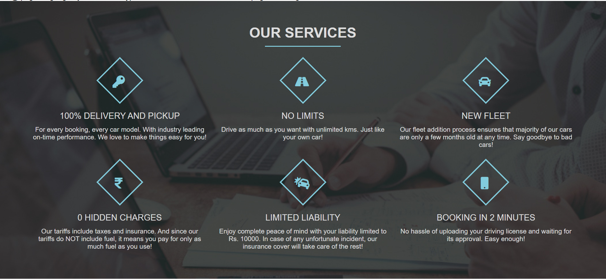

Code:

<!DOCTYPE html><html lang=*"en"* dir=*"ltr"*><head><meta charset=*"ISO-8859-1"*>

<link rel=*"stylesheet"* type=*"text/css"* href=*"service.css"*><meta name=*"viewport"* content=*"width=device-width, initial-scale=1"*>

<link rel=*"stylesheet"* href=*"https://use.fontawesome.com/releases/v5.7.2/css/all.css"*></head>

<body>

<div class=*"services-section"*><div class=*"inner-width"*>

<h1 class=*"section-title"*>Our Services</h1>

<div class=*"border"*></div>

<div class=*"services-container"*>

<div class=*"service-box"*> <div class=*"service-icon"*><i class=*"fa fa-key"*></i></div>

<div class=*"service-title"*>100% Delivery and Pickup</div>

<div class=*"service-desc"*>

For every booking, every car model. With industry leading on-time performance. We love to make things easy for you!

</div></div>

<div class=*"service-box"*> <div class=*"service-icon"*><i class=*"fas fa-road"*></div>

<div class=*"service-title"*>No Limits</div>

<div class=*"service-desc"*>

Drive as much as you want with unlimited kms. Just like your own car!

</div></div>

<div class=*"service-box"*><div class=*"service-icon"*><i class=*"fas fa-car"*></i></div>

<div class=*"service-title"*>New Fleet</div>

<div class=*"service-desc"*>

Our fleet addition process ensures that majority of our cars are only a few months old at any time. Say goodbye to bad cars!

</div></div>

<div class=*"service-box"*><div class=*"service-icon"*><i class=*"fa fa-rupee-sign"*></i></div>

<div class=*"service-title"*>0 Hidden Charges</div>

<div class=*"service-desc"*>

Our tariffs include taxes and insurance. And since our tariffs do NOT include fuel, it means you pay for only as much fuel as you use!

</div> </div>

<div class=*"service-box"*><div class=*"service-icon"*><i class=*"fa fa-car-crash"*></i> </div>

<div class=*"service-title"*>Limited Liability</div>

<div class=*"service-desc"*>

Enjoy complete peace of mind with your liability limited to Rs. 10000. In case of any unfortunate incident, our insurance cover will take care of the rest!

</div> </div>

<div class=*"service-box"*> <div class=*"service-icon"*><i class=*"fa fa-mobile"*></i> </div>

<div class=*"service-title"*>Booking in 2 Minutes</div>

<div class=*"service-desc"*>

No hassle of uploading your driving license and waiting for its approval. Easy enough!

</div></div></div> </div> </div></body></html>

**Contact page**

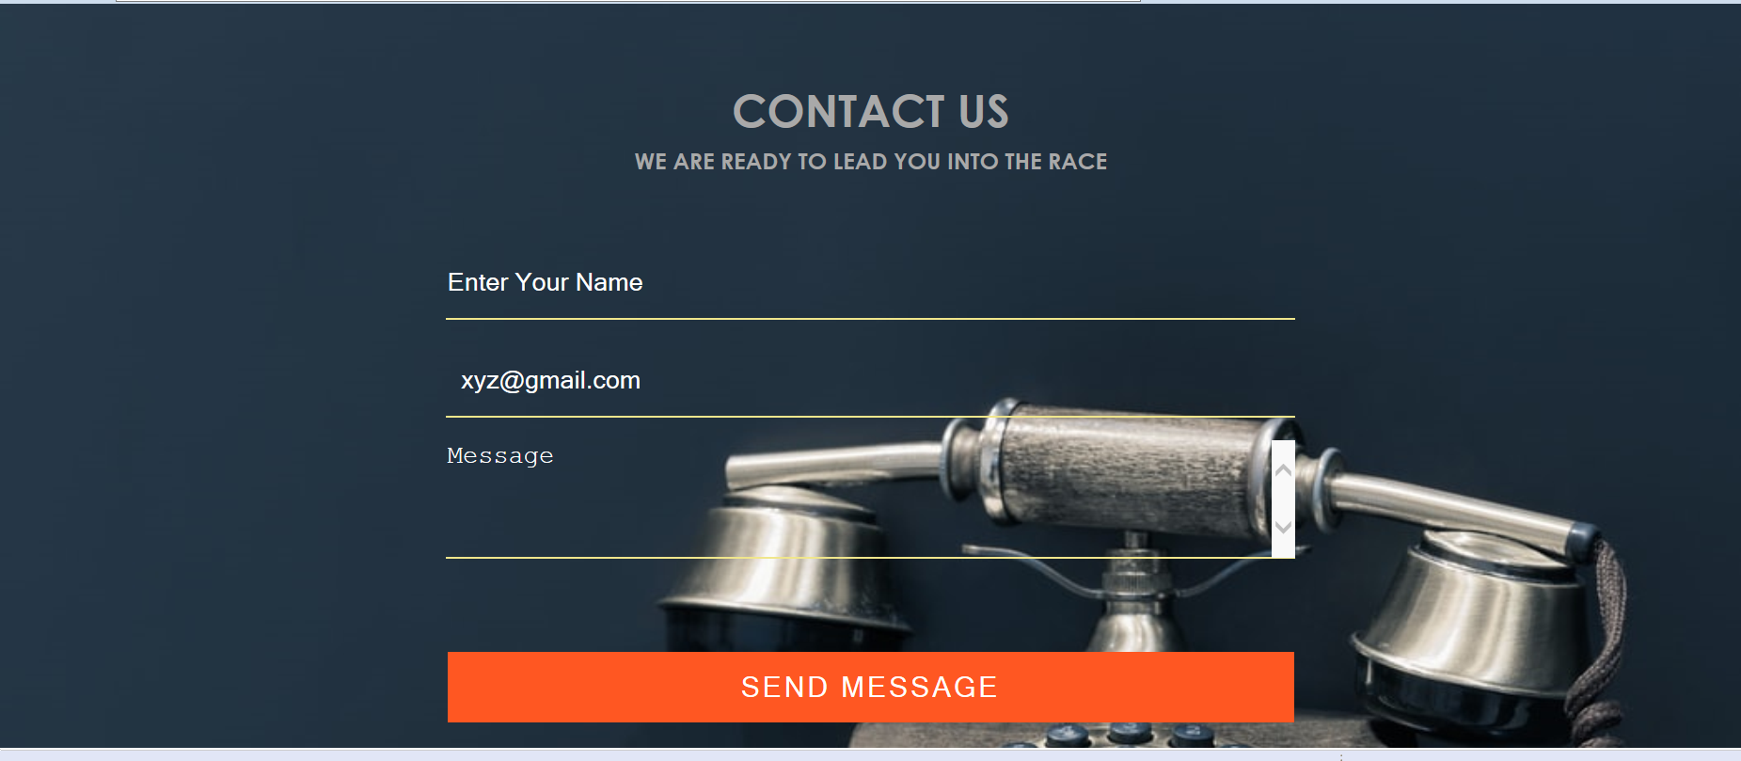

Code:

<!DOCTYPE html><html><head><meta charset=*"ISO-8859-1"*>

<link rel=*"stylesheet"* type=*"text/css"* href=*"contact.css"*></head>

<body>

<div class=*"title"*>

<h1>CONTACT US</h1>

<h2>WE ARE READY TO LEAD YOU INTO THE RACE</h2>

</div>

<div class=*"box"*>

<form method=*"post"* action=*"./contact"*>

<input type=*"text"* id=*"name"* name=*"name"* class=*"form-control"*placeholder=*"Enter Your Name"* required><br>

<input type=*"email"* name=*"email"* class=*"form-control"*placeholder=*" xyz@gmail.com"* required><br>

<textarea name=*"message"* class=*"form-control"* placeholder=*"Message"* rows=*"4"* required></textarea><br>

<input type=*"submit"* name=*""* class=*"form-control submit"* value=*"SEND MESSAGE"*>

</form></div></body></html>

**Feedback Page**

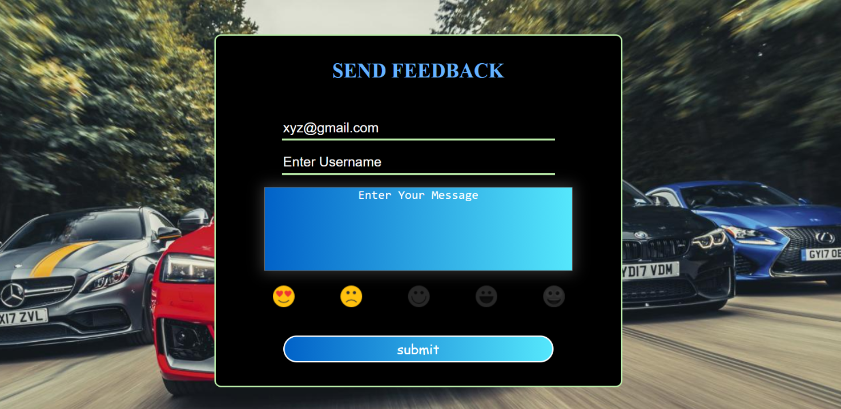

Code:

<!DOCTYPE html><html lang=*"en"*><head><meta charset=*"ISO-8859-1"*>

<meta charset=*"UTF-8"*><meta name=*"viewport"* content=*"width=device-width, initial-scale=1.0"*>

<title>feedback</title>

<link rel=*"stylesheet"* type=*"text/css"* href=*"newfeedback.css"*></head>

<body>

<div class=*"cont"*>

<form action=*"./feedback"* method=*"post"* >

<div class=*"form"*><div class=*"header"*>

<h3>Send Feedback</h3></div>

<div class=*"user"*>

<input type=*"email"* name=*"email"*placeholder=*"Enter Your Email id xyz@gmail.com "* value=*"xyz@gmail.com"*required>

</div>

<div class=*"username"*><input type=*"text"* name=*"user"*placeholder=*"Enter Username"*required>

</div><br>

<textarea placeholder=*"Enter Your Message"* class=*"textarea"* name=*"message"*></textarea><br><br>

<div class=*"rating"*>

<input type=*"radio"* name=*"emoji"* id=*"emoji1"* checked>

<label for=*"emoji1"*><img src=*"images/Satisfactory.png"* title=*"Satisfactory"*>

<input type=*"radio"* name=*"service"* id=*"emoji"* value=*"Satisfactory"*checked>Satisfactory<br>

</label>

<input type=*"radio"* name=*"emoji"* id=*"emoji2"* checked>

<label for=*"emoji2"*><img src=*"images/Happy.png"* title=*"Happy"*><br>

<input type=*"radio"* name=*"service"* id=*"emoji"* value=*"Happy"*checked>Happy<br>

</label>

<input type=*"radio"* name=*"emoji"* id=*"emoji3"* value=*""* checked>

<label for=*"emoji3"*><img src=*"images/Good.png"* title=*"Good"*><br>

<input type=*"radio"* name=*"service"* id=*"emoji"* value=*"Good"*checked>Good<br>

</label>

<input type=*"radio"* name=*"emoji"* id=*"emoji4"* checked>

<label for=*"emoji4"*><img src=*"images/Not Good.png"* title=*"Not Good"*><br>

<input type=*"radio"* id=*"emoji"* name=*"service"* value=*"Not Good"*checked>Not Good<br>

</label>

<input type=*"radio"* name=*"emoji"* id=*"emoji5"* checked>

<label for=*"emoji5"*><img src=*"images/Excellent.png"* title=*"Excellent"*><br>

<input type=*"radio"* name=*"service"* id=*"emoji"*value=*"Excellent"*checked>Excellent<br>

</label></div>

<div class=*"sub"*><input type=*"submit"* id=*"subject"* value=*"submit"*>

</div></div></form></div></body></html>

**Booking Page**

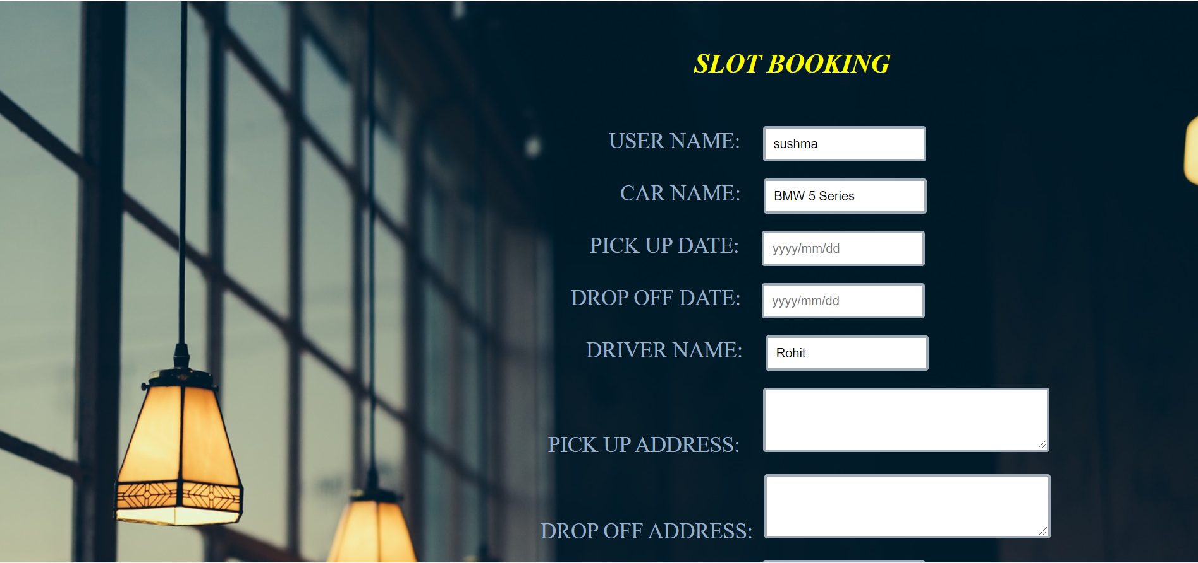

Code

<%@page language=*"java"* contentType=*"text/html; charset=ISO-8859-1"* pageEncoding=*"ISO-8859-1"*%>

<!DOCTYPE html><html><head><meta charset=*"ISO-8859-1"*>

<title>rover 1</title>

<link rel=*"stylesheet"* type=*"text/css"* href=*"book.css"*>

<link rel=*"stylesheet"* href=*"//code.jquery.com/ui/1.12.1/themes/base/jquery-ui.css"*>

<script src=*"https://code.jquery.com/jquery-1.12.4.js"*></script>

<script src=*"https://code.jquery.com/ui/1.12.1/jquery-ui.js"*></script>

<script>

$(**function** () {

**var** minDate=**new** Date();

$('#datepicker').datepicker

({minDate:'minDate',

showAnim:'drop',

dateFormat: 'yy-mm-dd',

autoclose: **true**,

todayHighlight: **true**,

showOtherMonths: **true**,

selectOtherMonths: **true**,

autoclose: **true**,

changeMonth: **true**,

changeYear: **true**,

orientation: "button"

}); });

$(**function** () {

**var** minDate=**new** Date();

$('#datepicker1').datepicker

({minDate:'minDate',

showAnim:'drop',

dateFormat: 'yy-mm-dd',

autoclose: **true**,

todayHighlight: **true**,

showOtherMonths: **true**,

selectOtherMonths: **true**,

autoclose: **true**,

changeMonth: **true**,

changeYear: **true**,

orientation: "button"

}); });

</script>

<script>

**function** check()

{

**var** date1 = **new** Date(frm.t1.value);

**var** date2 = **new** Date(frm.t2.value);

**var** diff = date2.getTime() - date1.getTime();

**var** msInDay = 1000 * 3600 * 24;

**if**( diff/msInDay >20){

alert("bookings available upto 20days");

}

}

**function** daysDifference() {

//define two variables and fetch the input from HTML form

**var** dateI1 = document.getElementById("datepicker").value;

**var** dateI2 = document.getElementById("datepicker1").value;

//define two date object variables to store the date values

**var** date1 = **new** Date(dateI1);

**var** date2 = **new** Date(dateI2);

//calculate time difference

**var** time_difference = date2.getTime() - date1.getTime();

//calculate days difference by dividing total milliseconds in a day

**var** result = time_difference / (1000 * 60 * 60 * 24) ;

**var** total_amount=(result*7000);

**return** document.getElementById("total_amount").value =

total_amount;

}

**function** myButton(){

location.reload();

}

</script></head>

<body class=*"book"*>

<h1>&nbsp;&nbsp;&nbsp;&nbsp;&nbsp;&nbsp;&nbsp;&nbsp;&nbsp;&nbsp;&nbsp;&nbsp;&nbsp;&nbsp;&nbsp;&nbsp;

SLOT BOOKING</h1>

<form id=*"reg"* method=*"post"* name=*"frm"* action=*"./rover"*>

&nbsp;&nbsp;&nbsp;&nbsp;&nbsp;&nbsp;&nbsp;&nbsp;&nbsp;&nbsp;&nbsp;&nbsp;&nbsp;&nbsp;&nbsp;&nbsp;&nbsp;

<label> USER NAME:</label>&nbsp;&nbsp;&nbsp;&nbsp;&nbsp;

<input type=*"text"* id=*"date"* value=*"*<%=session.getAttribute("uname") %>*"* name=*"name"* required=*"required"*><br><br>

&nbsp;&nbsp;&nbsp;&nbsp;&nbsp;&nbsp;&nbsp;&nbsp;&nbsp;&nbsp;&nbsp;&nbsp;&nbsp;&nbsp;&nbsp;&nbsp;&nbsp;&nbsp;&nbsp;&nbsp;

<label>CAR NAME:</label>&nbsp;&nbsp;&nbsp;&nbsp;&nbsp;

<input type=*"text"* id=*"date"* name=*"select"* value=*"RANGE ROVER"* readonly/><br><br>

&nbsp;&nbsp;&nbsp;&nbsp;&nbsp;&nbsp;&nbsp;&nbsp;&nbsp;&nbsp;&nbsp;&nbsp;

<label>PICK UP DATE:</label>&nbsp;&nbsp;&nbsp;&nbsp;&nbsp;

<input type=*"text"* name=*"t1"* placeholder=*"yyyy/mm/dd"* id=*"datepicker"*required=*"required"*><br><br>

&nbsp;&nbsp;&nbsp;&nbsp;&nbsp;&nbsp;&nbsp;

<label>DROP OFF DATE: </label>&nbsp;&nbsp;&nbsp;

<input type=*"text"*name=*"t2"* onclick="check()" placeholder=*"yyyy/mm/dd"* id=*"datepicker1"*required=*"required"*><br><br>

&nbsp;&nbsp;&nbsp;&nbsp;&nbsp;&nbsp;&nbsp;&nbsp;&nbsp;&nbsp;&nbsp;

<label> DRIVER NAME:</label>&nbsp;&nbsp;&nbsp;&nbsp;&nbsp;

<input type=*"text"* name=*"t3"* placeholder=*""* id=*"driver"* value=*"Santhosh"* readonly/> <br><br>

&nbsp;

<label>PICK UP ADDRESS:</label>&nbsp;&nbsp;&nbsp;&nbsp;&nbsp;

<textarea placeholder=*""* name=*"t4"* id=*"name"* rows=*"3"*required=*"required"*></textarea><br><br>

<label>DROP OFF ADDRESS:</label>&nbsp;&nbsp;

<textarea placeholder=*""* name=*"t5"* id=*"name"* rows=*"3"* required=*"required"*></textarea><br><br>

<label> REGISTRATION NO:</label>&nbsp;&nbsp;&nbsp;&nbsp;&nbsp;

<input type=*"text"* name=*"t6"* class=*"pay"* id=*"Registration"* value=*"TS 01C A 2255"* readonly/><br><br>

&nbsp;&nbsp;&nbsp;&nbsp;&nbsp;&nbsp;&nbsp;&nbsp;&nbsp;&nbsp;&nbsp;&nbsp;&nbsp;&nbsp;&nbsp;&nbsp;&nbsp;&nbsp;&nbsp;&nbsp;&nbsp;&nbsp;&nbsp;&nbsp;&nbsp;&nbsp;&nbsp;&nbsp;&nbsp;&nbsp;

<label>CAR ID :</label>&nbsp;&nbsp;&nbsp;&nbsp;&nbsp;

<input type=*"number"* name=*"t7"* class=*"pay"* id=*"ID"* value=*"106"* readonly/> <br><br>

&nbsp;&nbsp;&nbsp;&nbsp;

<label>TOTAL AMOUNT :</label>&nbsp;&nbsp;&nbsp;&nbsp;&nbsp;

<input type=*"text"* name=*"t8"* id=*"total_amount"* readonly/><br><br>

&nbsp;&nbsp;&nbsp;&nbsp;&nbsp;&nbsp;&nbsp;&nbsp;&nbsp;&nbsp;&nbsp;&nbsp;&nbsp;&nbsp;

<a href=*"homepage.jsp"* class=*"btn"*>BACK</a>&nbsp;&nbsp;&nbsp;&nbsp;

<button type=*"button"* name=*"button"* class=*"bttn"* onclick="daysDifference()">TOTAL PAYMENT</button>&nbsp;&nbsp;&nbsp;&nbsp;

<input class=*"btn"* type=*"reset"* name=*"button"* value=*"RESET"* id=*"some"* onclick="myButton()">&nbsp;&nbsp;<br>

&nbsp;&nbsp;&nbsp;&nbsp;&nbsp;&nbsp;&nbsp;&nbsp;&nbsp;&nbsp;&nbsp;&nbsp;&nbsp;&nbsp;&nbsp;&nbsp;&nbsp;&nbsp;&nbsp;&nbsp;&nbsp;&nbsp;&nbsp;&nbsp;&nbsp;&nbsp;&nbsp;&nbsp;&nbsp;&nbsp;&nbsp;&nbsp;&nbsp;&nbsp;&nbsp;&nbsp;&nbsp;&nbsp; &nbsp;&nbsp;&nbsp;&nbsp;&nbsp;&nbsp;&nbsp;&nbsp;

<input type=*"submit"* class=*"btn"* name=*"button"* value=*"BOOK"*>&nbsp;&nbsp;

<br><br><br></form><br><br></body></html>

**Carslist page**

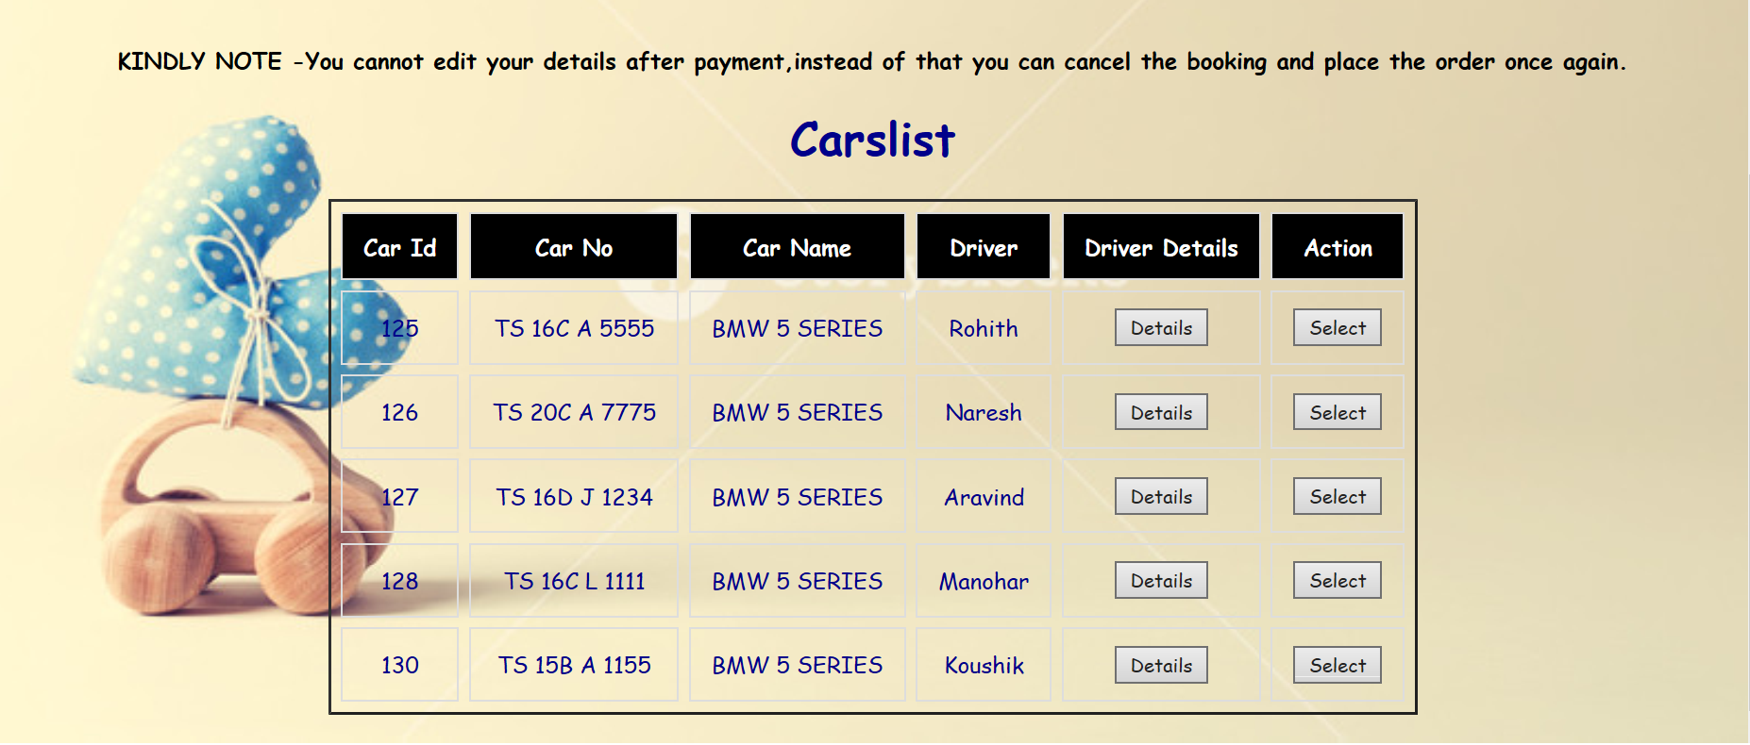

Code:

<!DOCTYPE html><html><head><meta charset=*"ISO-8859-1"*>

<title>Insert title here</title>

<link rel=*"stylesheet"* type=*"text/css"* href=*"table.css"*></head>

<body><br><br><br><br><br><br>

<div class=*"table-responsive"*>

<center><h4>KINDLY NOTE -You cannot edit your details after payment,instead of that you can cancel the booking and place the order once again.</h4></center>

<center><h1>Carslist</h1></center></div>

<table class=*"content-table"* cellpadding=*"7"* cellspacing=*"7"* border=*"2"* align=*"center"*>

<thead><tr>

<th>Car Id</th>

<th>Car No</th>

<th> Car Name</th>

<th>Driver </th>

<th>Driver Details</th>

<th>Action </th>

</tr>

<tr>

<td>125</td>

<td>TS 16C A 5555</td>

<td> BMW 5 SERIES </td>

<td>Rohith</td>

<td><a href=*"rohit.html"* class=*"link"*><button type=*"button"* class=*"delete"*>Details</button></a> </td>

<td><a href=*"bmwavail-1.jsp"* class=*"link"*><button type=*"button"* class=*"delete"*>Select</button></a></td>

</tr>

<tr>

<td>126</td>

<td>TS 20C A 7775</td>

<td> BMW 5 SERIES </td>

<td>Naresh</td>

<td><a href=*"naresh.html"* class=*"link"*><button type=*"button"* class=*"delete"*>Details</button></a> </td>

<td><a href=*"bmwavail-2.jsp "* class=*"link"*><button type=*"button"* class=*"delete"*>Select</button></a></td></tr>

<tr>

<td>127</td>

<td>TS 16D J 1234</td>

<td> BMW 5 SERIES </td>

<td>Aravind</td>

<td><a href=*"aravind.html"* class=*"link"*><button type=*"button"* class=*"delete"*>Details</button></a> </td>

<td><a href=*"bmwavail-3.jsp"* class=*"link"*><button type=*"button"* class=*"delete"*>Select</button></a></td></tr>

<tr>

<td>128</td>

<td>TS 16C L 1111</td>

<td> BMW 5 SERIES </td>

<td>Manohar</td>

<td><a href=*"manohar.html"* class=*"link"*><button type=*"button"* class=*"delete"*>Details</button></a> </td>

<td><a href=*"bmwavail-4.jsp"* class=*"link"*><button type=*"button"* class=*"delete"*>Select</button></a></td></tr>

<tr>

<td>130</td>

<td>TS 15B A 1155</td>

<td> BMW 5 SERIES </td>

<td>Koushik</td>

<td><a href=*"koushik.html"* class=*"link"*><button type=*"button"* class=*"delete"*>Details</button></a> </td>

<td><a href=*"bmwavail-5.jsp"* class=*"link"*><button type=*"button"* class=*"delete"*>Select</button></a></td></tr>

<table></body></html>

**Driver page**

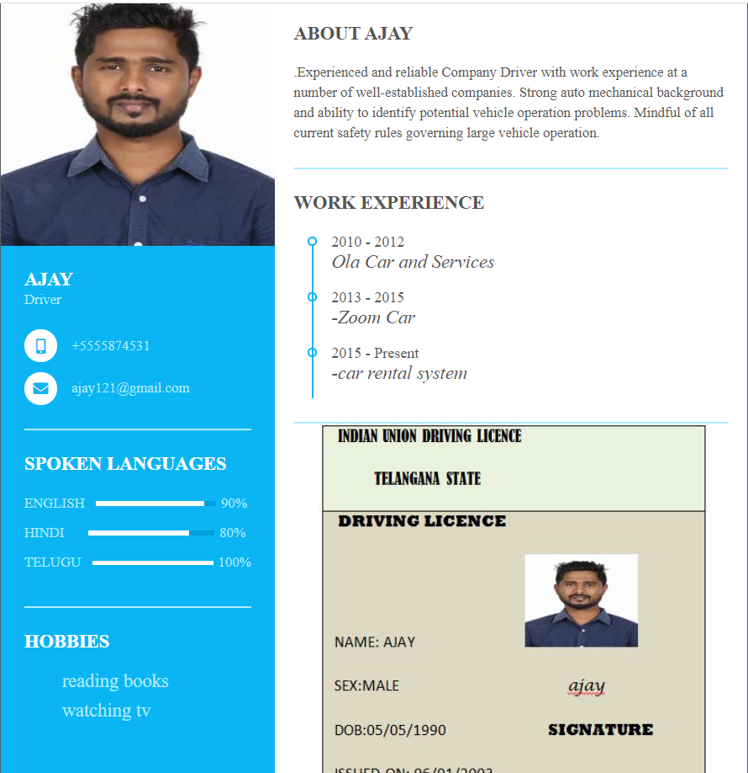

<!DOCTYPE html><html><head><meta charset=*"ISO-8859-1"*>

<title>ajay</title>

<link rel=*"stylesheet"* type=*"text/css"* href=*"driver.css"*>

<script src=*"https://kit.fontawesome.com/b99e675b6e.js"*></script></head>

<body>

<div class=*"resume"*>

<div class=*"resume_left"*>

<div class=*"resume_profile"*><img src=*"images/Ajay.jpg"* alt=*"profile_pic"*></div>

<div class=*"resume_content"*>

<div class=*"resume_item resume_info"*>

<div class=*"title"*><p class=*"bold"*>AJAY</p><p class=*"regular"*>Driver</p></div>

<ul><li>

<div class=*"icon"*><i class=*"fas fa-mobile-alt"*></i> </div><div class=*"data"*> +5555874531</div></li>

<li><div class=*"icon"*><i class=*"fas fa-envelope"*></i></div>

<div class=*"data"*> ajay121@gmail.com </div>

</ul></div>

<div class=*"resume_item resume_skills"*>

<div class=*"title"*> <p class=*"bold"*>SPOKEN LANGUAGES</p> </div>

<ul><li>

<div class=*"skill_name"*> ENGLISH </div>

<div class=*"skill_progress"*> <span style="width: *90%*;"></span> </div>

<div class=*"skill_per"*>90%</div>

</li>

<li><div class=*"skill_name"*>HINDI </div>

<div class=*"skill_progress"*> <span style="width: *80%*;"></span></div>

<div class=*"skill_per"*>80%</div></li>

<li><div class=*"skill_name"*> TELUGU </div>

<div class=*"skill_progress"*> <span style="width: *100%*;"></span> </div>

<div class=*"skill_per"*>100%</div></li></ul>

</div>

<div class=*"resume_item resume_education"*>

<div class=*"title"*>

<p class=*"bold"*>hobbies</p>

</div>

<ul>

<li><div class=*"info"*> <p class=*"semi-bold"*>reading books</p></div></li>

<li><div class=*"info"*> <p class=*"semi-bold"*>watching tv</p></div></li></ul>

</div></div></div>

<div class=*"resume_right"*>

<div class=*"resume_item resume_about"*>

<div class=*"title"*><p class=*"bold"*>About Ajay</p></div>

<p>.Experienced and reliable Company Driver with work experience at a number of well-established companies. Strong auto mechanical background and ability to identify potential vehicle operation problems. Mindful of all current safety rules governing large vehicle operation. </p></div>

<div class=*"resume_item resume_work"*>

<div class=*"title"*> <p class=*"bold"*>Work Experience</p> </div>

<ul><li>

<div class=*"date"*>2010 - 2012 &nbsp;&nbsp;&nbsp;&nbsp;&nbsp;&nbsp;&nbsp;&nbsp;&nbsp;&nbsp;

<div class=*"info"*><i class=*"semi-bold"*> Ola Car and Services</i></div></div></li>

<li>

<div class=*"date"*>2013 - 2015 &nbsp;&nbsp;&nbsp;&nbsp;&nbsp;&nbsp;&nbsp;&nbsp;&nbsp;&nbsp; <div class=*"info"*><i class=*"semi-bold"*>-Zoom Car</i></div></div></li>

<li><div class=*"date"*>2015 - Present &nbsp;&nbsp;&nbsp;&nbsp;&nbsp;&nbsp;&nbsp;&nbsp;&nbsp;&nbsp; <div class=*"info"*><i class=*"semi-bold"*>-car rental system</i></div></div></li>

</li></ul></div><br>

<div class=*"license"*> &nbsp;&nbsp;&nbsp;&nbsp;&nbsp;&nbsp;

<img src=*"images\ajay DL.JPG"* class=*"image"* alt=*"profile_pic"*>

</div></div></div></body></html>

**Payment page**

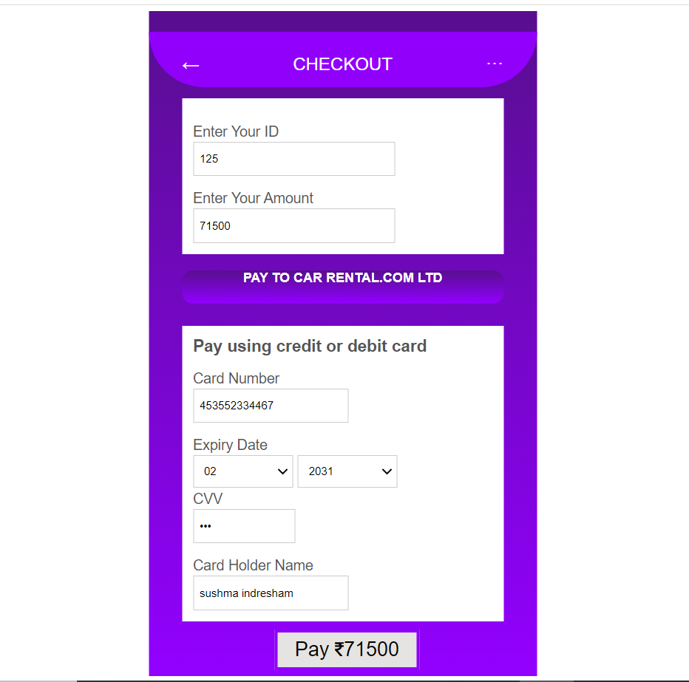

Code

<%@page language=*"java"* contentType=*"text/html; charset=ISO-8859-1"* pageEncoding=*"ISO-8859-1"*%>

<%@page import=*"java.sql.*"*%> <%@page import=*"java.sql.DriverManager"*%>

<%@page import=*"java.sql.ResultSet"*%><%@page import=*"java.sql.Statement"*%>

<%@page import=*"java.sql.Connection"*%>

<!DOCTYPE html><html><head><meta charset=*"ISO-8859-1"*>

<title>Insert title here</title>

<link rel=*"stylesheet"* type=*"text/css"* href=*"payment.css"*>

<link rel=*"stylesheet"* href=*"https://cdnjs.cloudflare.com/ajax/libs/font-awesome/4.7.0/css/font-awesome.min.css"*>

</head>

<body>

<div class=*"app-container"*>

<form method=*"post"* action=*"./payment"*><BR>

<div class=*"top-box"*>

<p><span class=*"left-icon"*>&#x2190;</span>CHECKOUT<span class=*"right-icon"*>&#xb7;&#xb7;&#xb7;</span></p>

</div>

<div class=*"other"*>

<div class=*"enterid"*>

<label>Enter Your ID</label><br>

<input type=*"number"* name=*"t1"* class=*"idfield"* value=*"*<%=session.getAttribute("t7") %>*"* placeholder=*"xxx"* maxlength=*"3"* readonly/></div>

<div class=*" amount"*>

<label> Enter Your Amount</label><br>

<input type=*"number"* name=*"t2"*class=*"amountfield"* value=*"*<%=session.getAttribute("t8") %>*"* placeholder=*"Enter Amount"* maxlength=*"10"* readonly/></div>

</div> <br> <br> <br> <br>

<div class=*"middle-box"*><p><b>PAY TO CAR RENTAL.COM LTD</b></p></div>

<div class=*"card-details"*>

<p><b>Pay using credit or debit card</b></p>

<div class=*"card-num-field-group"*>

<label>Card Number</label><br>

<input type=*"number"* class=*"card-num-field"* name=*"t3"* placeholder=*"xxxx-xxxx-xxxx-xxxx"* maxlength=*"12"* required></div>

<div class=*"date-field-group"*>

<label>Expiry Date</label><br>

<select style="width:*90px*" name=*"t4"* class=*"date-field"* id=*"date-field"* required>

<option id=*"option"* value=*""*>Month</option>

<option >01</option><option >02</option><option >03</option><option >04</option>

<option >05</option><option >06</option><option >07</option><option >08</option>

<option >09</option><option >10</option><option >11</option><option >12</option>

</select>

<select style="width:*90px*" name=*"t5"* class=*"date-field"* id=*"date-field"* required>

<option id=*"option"* value=*""*>Year</option>

<option >2021</option><option >2022</option><option >2023</option><option >2024</option>

<option >2025</option><option >2026</option><option >2027</option><option >2028</option>

<option >2029</option><option >2030</option><option >2031</option><option >2032</option>

<option >2033</option><option >2034</option><option >2035</option><option >2036</option>

<option >2037</option><option >2038</option><option >2039</option><option >2040</option>

<option >2041</option><option >2042</option><option >2043</option><option >2044</option>

<option >2045</option><option >2046</option><option >2047</option><option >2048</option>

<option >2049</option><option >2050</option>

</select>

</div>

<div class=*"cvc-field-group"*>

<label> CVV</label><br>

<input type=*"password"* name=*"t6"* class=*"cvv-field"* placeholder=*"xxx"* maxlength=*"3"*></div>

<div class=*"name-field-group"*>

<label>Card Holder Name</label><br>

<input type=*"text"* name=*"t7"* class=*"name-field"* placeholder=*"Full Name"* required></div>

<div class=*"button"*>&nbsp;&nbsp;

<button type=*"submit"* class=*"btn"* name=*"button"* value=*""*>Pay&nbsp;<i class=*"fa fa-rupee"* style="fontsize:*16px*"></i><%=session.getAttribute("t8")%></button

&nbsp;&nbsp;&nbsp;&nbsp;&nbsp;&nbsp;&nbsp;&nbsp;&nbsp;&nbsp;

</div></div></form></div></body></html>

**Thankyoupage**

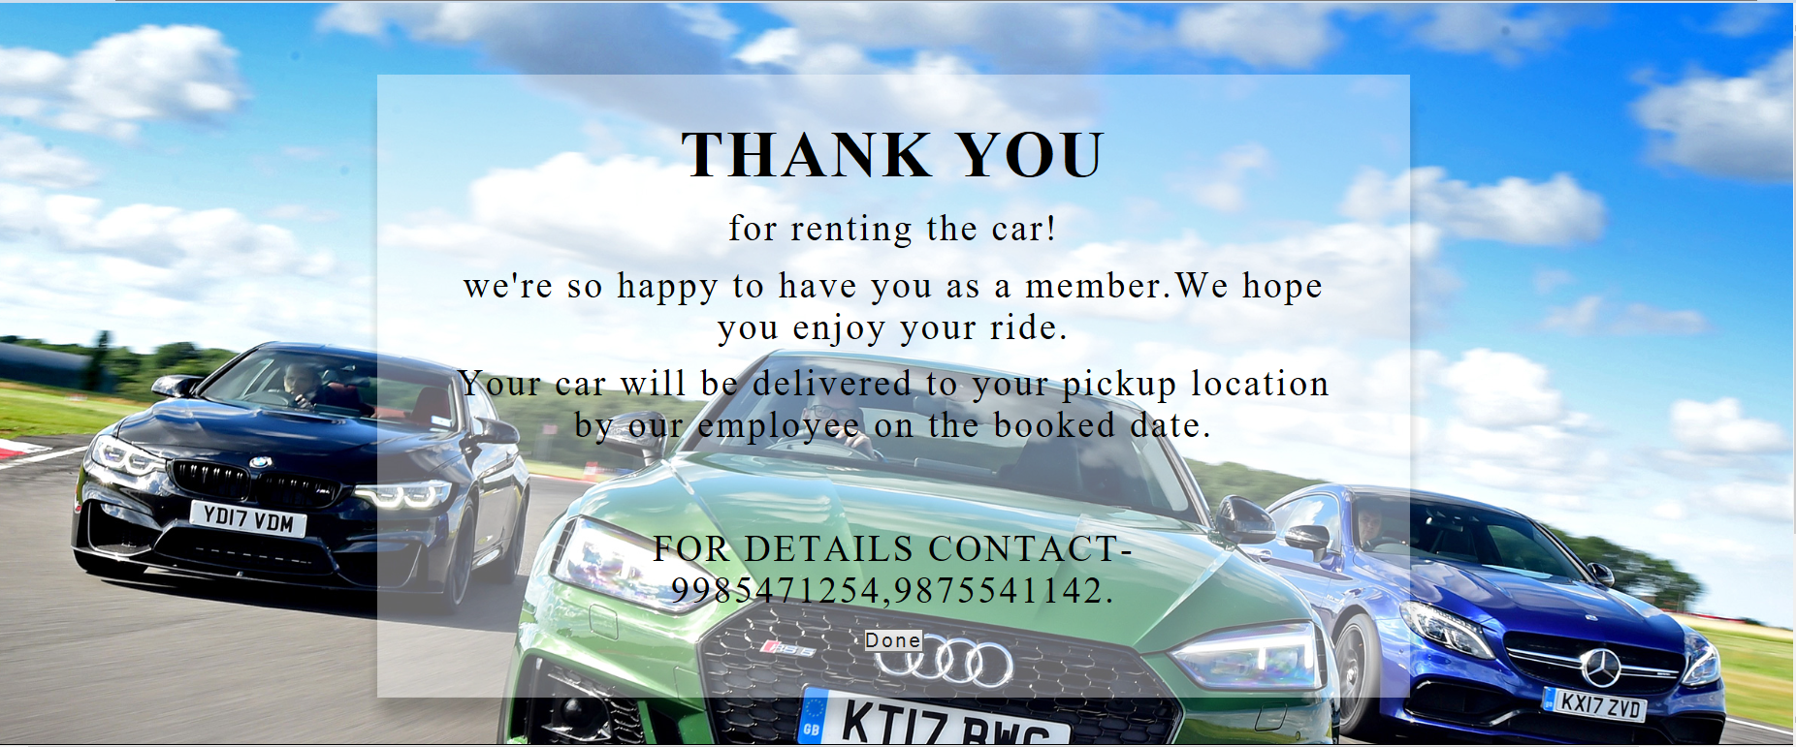

Code

<!DOCTYPE html><html><head><meta charset=*"ISO-8859-1"*>

<title>Transparent Division Box</title>

<link rel=*"stylesheet"* type=*"text/css"* href=*"finalpayment.css"*></head>

<body>

<div class=*"Box"*><div class=*"Inner_Box"*>

<h1>THANK YOU</h1>

<p>for renting the car! </p>

<p>we're so happy to have you as a member.We hope you enjoy your ride.</p>

<p> Your car will be delivered to your pickup location by our employee on the booked date. </p>

<br><br>

<p>FOR DETAILS CONTACT-9985471254,9875541142.</p>

<a href=*"homepage.jsp"* class=*"link"*><button type=*"button"* class=*"delete"*>Done</button></a>

</div></div></body></html>

**Viewbooking page**

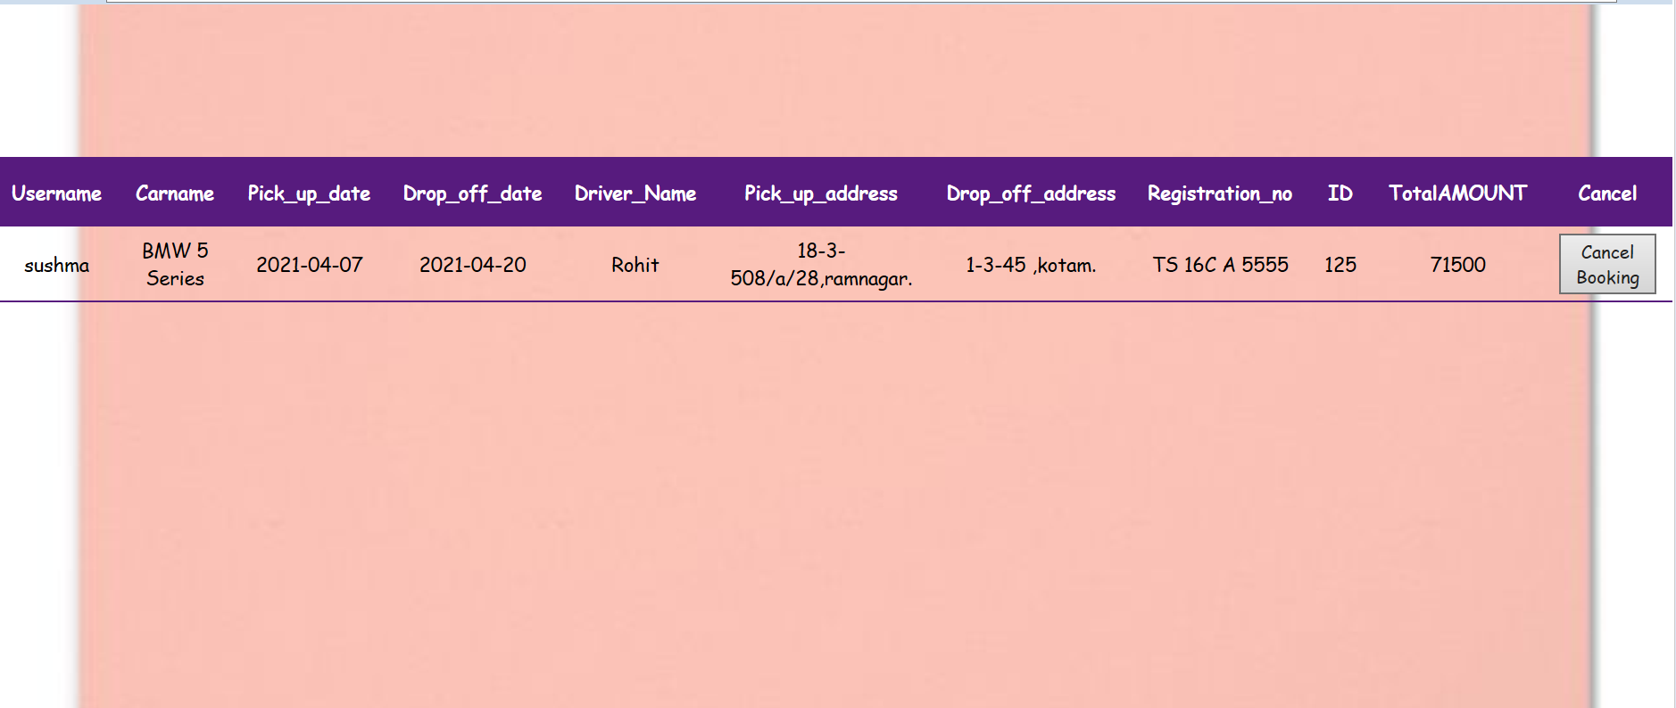

Code:

<%@page language=*"java"* contentType=*"text/html; charset=ISO-8859-1"*pageEncoding=*"ISO-8859-1"*%>

<%@page import=*"java.sql.*"*%> <%@page import=*"java.sql.DriverManager"*%>

<%@page import=*"java.sql.ResultSet"*%><%@page import=*"java.sql.Statement"*%>

<%@page import=*"java.sql.Connection"*%>

<!DOCTYPE html><html><head><meta charset=*"ISO-8859-1"*>

<title>search</title>

<link rel=*"stylesheet"* type=*"text/css"* href=*"viewbooking.css"*></head>

<body><br><br><br><br>

<table class=*"content-table"* align=*"center"*>

<thead><tr>

<th>Username</th><th>Carname</th><th> Pick_up_date</th><th> Drop_off_date</th><th>Driver_Name</th><th>Pick_up_address </th>

<th>Drop_off_address </th><th>Registration_no </th><th>ID </th><th>TotalAMOUNT</th><th>Cancel</th>

</tr></thead><tbody>

<% String n=(String)session.getAttribute("uname"); %>

<%

**try**{

Class.forName("com.mysql.jdbc.Driver");

Connection conn=DriverManager.getConnection("jdbc:mysql://localhost:3306/sushma1","root","root"); String Query ="select * from slotbooking where username='"+n+"'";

Statement stm =conn.createStatement();

ResultSet rs=stm.executeQuery(Query);

**while**(rs.next()){

%>

<tr>

<td><%=rs.getString("username")%></td>

<td><%=rs.getString("Carname")%></td>

<td><%=rs.getString("Pick_up_date") %></td>

<td><%=rs.getString("Drop_off_date") %> </td>

<td><%=rs.getString("Drivername") %></td>

<td><%=rs.getString("Pick_up_address") %> </td>

<td><%=rs.getString("Drop_off_address") %> </td>

<td><%=rs.getString("Registrationno") %></td>

<td><%=rs.getString("ID") %></td>

<td><%=rs.getString("Totalamount") %></td>

<td><a href=*"delete.jsp?d=*<%=rs.getString("ID") %>*"*><button type=*"button"* class=*"delete"*>Cancel Booking</button></a></td>

</tr><%

}}

**catch**(Exception ex)

{System.out.println(ex.getMessage());}%></tbody></table></body></html>

**Car not Available**

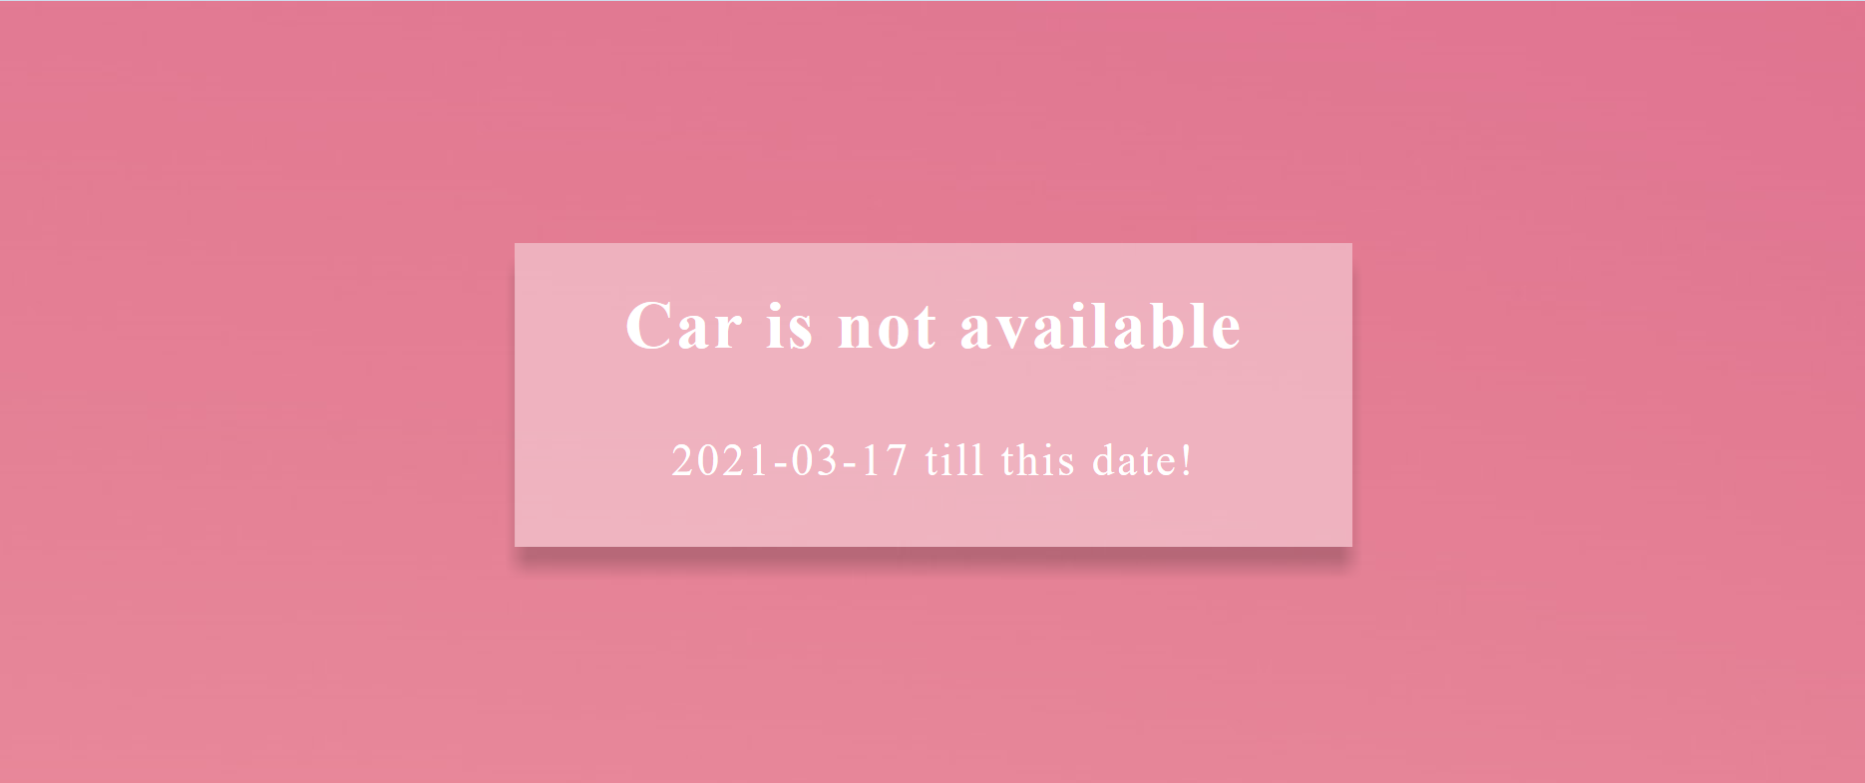

Code:

<%@page language=*"java"* contentType=*"text/html; charset=ISO-8859-1"* pageEncoding=*"ISO-8859-1"*%>

<%@page import=*"java.sql.*"*%> <%@page import=*"java.sql.DriverManager"*%>

<%@page import=*"java.sql.ResultSet"*%><%@page import=*"java.sql.Statement"*%>

<%@page import=*"java.sql.Connection"*%>

<!DOCTYPE html><html><head><meta charset=*"ISO-8859-1"*>

<title>Insert title here</title>

<link rel=*"stylesheet"* type=*"text/css"* href=*"deshaw.css"*></head>

<body>

<%

**try**{

Class.forName("com.mysql.jdbc.Driver");

Connection conn=DriverManager.getConnection("jdbc:mysql://localhost:3306/sushma1","root","root");

String Query ="select * from slotbooking where ID='116'";

Statement stm =conn.createStatement();

ResultSet rs=stm.executeQuery(Query);

**if** (rs.next()) {%>

<div class=*"Box"*><div class=*"Inner_Box"*>

<h1>Car is not available</h1><br><br>

<p><%=rs.getString("Drop_off_date") %> till this date!</p>

</div></div>

<%}

**else**{

response.sendRedirect("rover two.jsp");}}

**catch**(Exception ex){

out.println("Exception:" +ex.getMessage());

ex.printStackTrace();

}%></body></html>

**Admin page**

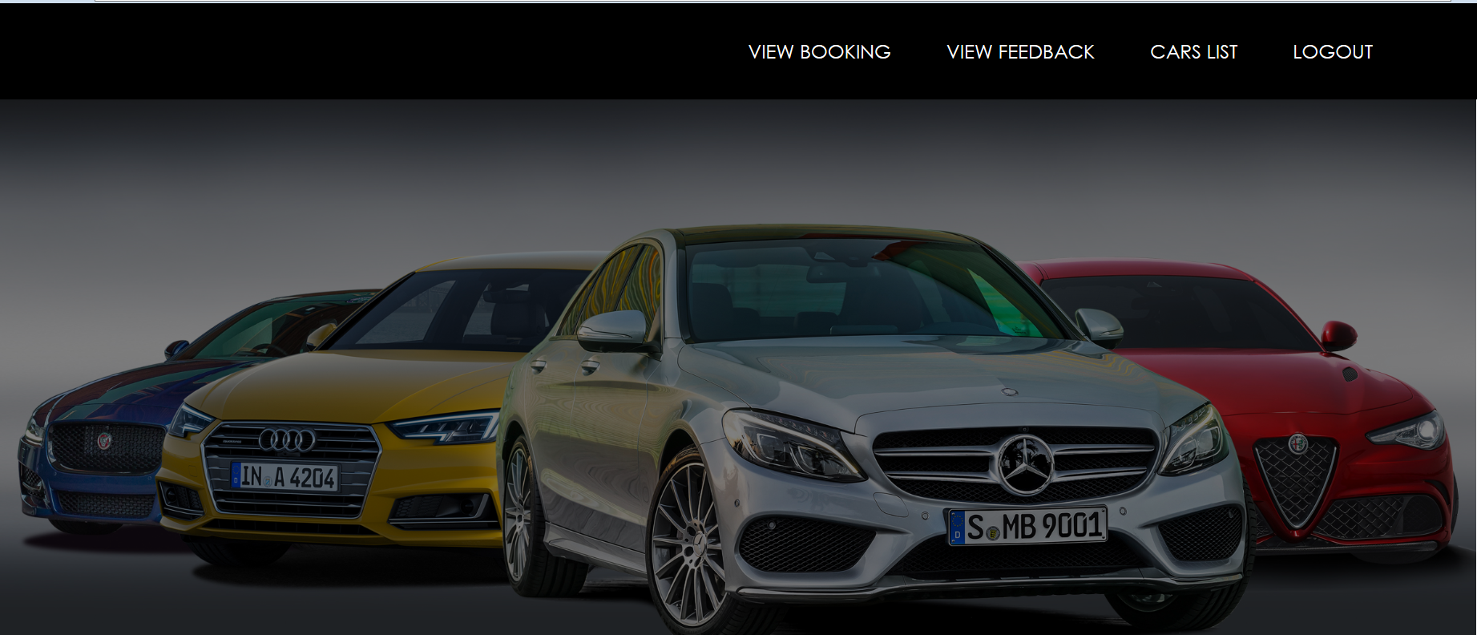

Code:

<%@ page language=*"java"* contentType=*"text/html; charset=ISO-8859-1"*

pageEncoding=*"ISO-8859-1"*%>

<!DOCTYPE html>

<html>

<head>

<meta charset=*"ISO-8859-1"*>

<title>adminpage</title>

<link href=*"https://stackpath.bootstrapcdn.com/bootstrap/4.1.3/css/bootstrap.min.css"* rel=*"stylesheet"*>

<link rel=*"stylesheet"* type=*"text/css"* href=*"adminpage.css"*>

</head>

<body><header><nav class=*"navbar navbar-expand-lg navbar-ligh t fixed-top"*>

<div class=*"container"*>

<div class=*"collapse navbar-collapse"* id=*"navbarSupportedContent"*>

<ul class=*"navbar-nav ml-auto"*>

<li class=*"nav-item"*><a class=*"nav-link"* href=*"viewbooking.jsp"*>VIEW BOOKING</a></li>

<li class=*"nav-item"*><a class=*"nav-link"* href=*"viewfeedback.jsp"*>VIEW FEEDBACK</a></li>

<li class=*"nav-item"*><a class=*"nav-link"* href=*"viewcarslist.jsp"*>CARS LIST</a></li>

<li class=*"nav-item"*><a class=*"nav-link"* href=*"logout.jsp"*>LOGOUT</a></li>

</ul></div></div></nav></header></body></html>

**Admin view booking**

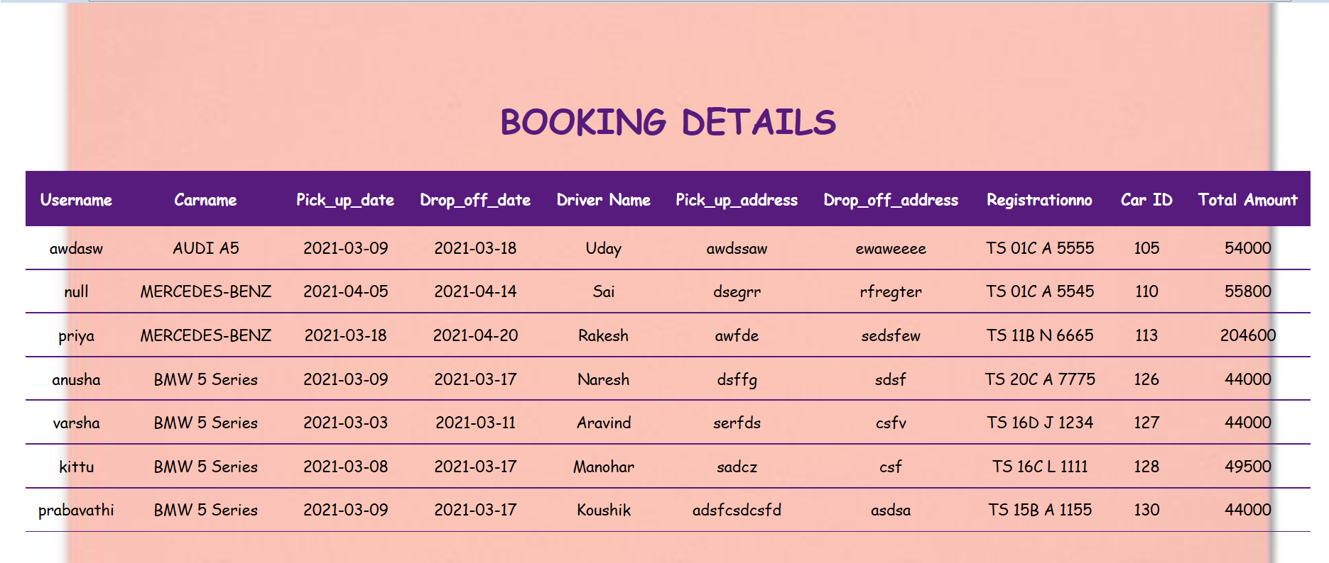

Code:

<%@page language=*"java"* contentType=*"text/html; charset=ISO-8859-1"*pageEncoding=*"ISO-8859-1"*%>

<%@page import=*"java.sql.*"*%> <%@page import=*"java.sql.DriverManager"*%>

<%@page import=*"java.sql.ResultSet"*%><%@page import=*"java.sql.Statement"*%>

<%@page import=*"java.sql.Connection"*%>

<!DOCTYPE html><html><head><meta charset=*"ISO-8859-1"*>

<title>Insert title here</title>

<link rel=*"stylesheet"* type=*"text/css"* href=*"adminview.css"*>

</head>

<body><br><br>

<div class=*"table-responsive"*><br><center><h1>BOOKING DETAILS</h1></center></div>

<table class=*"content-table"* align=*"center"*><thead><tr>

<th>Username</th><th>Carname</th><th> Pick_up_date</th><th> Drop_off_date</th><th>Driver Name</th><th>Pick_up_address </th>

<th>Drop_off_address </th><th>Registrationno </th><th> Car ID </th><th>Total Amount</th>

</tr><thead>

<tbody>

<% **try**{

Class.forName("com.mysql.jdbc.Driver");

Connection conn=DriverManager.getConnection("jdbc:mysql://localhost:3306/sushma1","root","root");

String Query ="select * from slotbooking";

Statement stm =conn.createStatement();

ResultSet rs=stm.executeQuery(Query);

**while**(rs.next()){ %>

<tr><td><%=rs.getString("username")%></td>

<td><%=rs.getString("Carname")%></td>

<td><%=rs.getString("Pick_up_date") %></td>

<td><%=rs.getString("Drop_off_date") %> </td>

<td><%=rs.getString("Drivername") %></td>

<td><%=rs.getString("Pick_up_address") %> </td>

<td><%=rs.getString("Drop_off_address") %> </td>

<td><%=rs.getString("Registrationno") %></td>

<td><%=rs.getString("ID") %></td>

<td><%=rs.getString("Totalamount") %></td></tr><%

}}

**catch**(Exception ex)

{

out.println("Exception:" +ex.getMessage());

ex.printStackTrace();

}%>

</tbody></table></body></html>

**Admin update and add car**

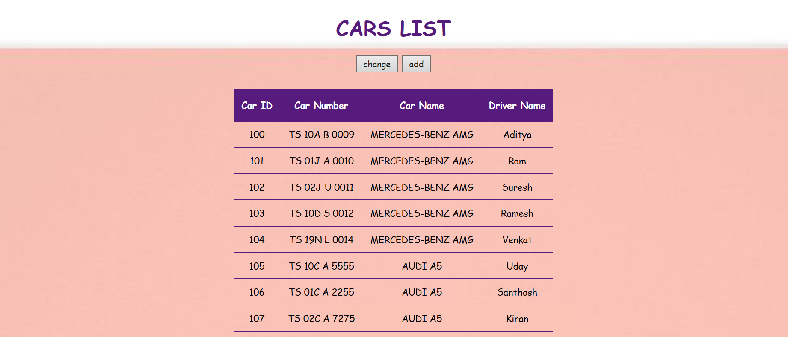

Code:

<%@page language=*"java"* contentType=*"text/html; charset=ISO-8859-1"*pageEncoding=*"ISO-8859-1"*%>

<%@page import=*"java.sql.*"*%> <%@page import=*"java.sql.DriverManager"*%>

<%@page import=*"java.sql.ResultSet"*%><%@page import=*"java.sql.Statement"*%>

<%@page import=*"java.sql.Connection"*%>

<!DOCTYPE html><html><head><meta charset=*"ISO-8859-1"*>

<title>Insert title here</title>

<link rel=*"stylesheet"* type=*"text/css"* href=*"adminview.css"*>

</head>

<body>

<div class=*"table-responsive"*><center><h1>CARS LIST</h1></center>

<a href=*"carsupdate.jsp"*><button type=*"button"* class=*"delete"*>change</button></a>

<a href=*"addnew.jsp"*><button type=*"button"* class=*"delete"*>add</button></a></div>

<table class=*"content-table"* align=*"center"*>

<thead>

<tr>

<th> Car ID </th><th>Car Number</th><th>Car Name</th><th>Driver Name</th>

</tr><thead>

<tbody>

<%

**try**{

Class.forName("com.mysql.jdbc.Driver");

Connection conn=DriverManager.getConnection("jdbc:mysql://localhost:3306/sushma1","root","root");

String Query ="select * from aval_cars";

Statement stm =conn.createStatement();

ResultSet rs=stm.executeQuery(Query);

**while**(rs.next()){

%>

<tr>

<td><%=rs.getString("Car_Id")%></td>

<td><%=rs.getString("Car_No")%></td>

<td><%=rs.getString("Car_Name") %></td>

<td><%=rs.getString("Driver_Name") %> </td>

</tr>

<%

}}

**catch**(Exception ex){

out.println("Exception:" +ex.getMessage());

ex.printStackTrace();

}

%>

</tbody></table></body></html>

**Addcar:**

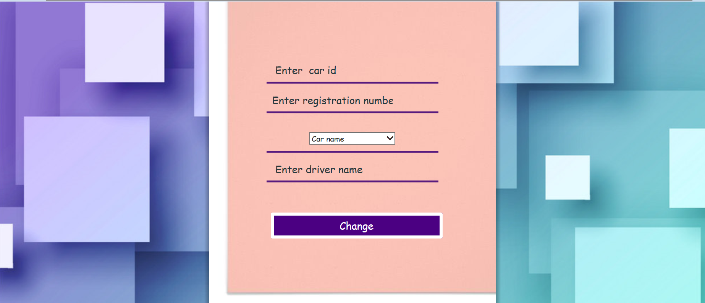

Code:

<!DOCTYPE html><html><head><meta charset="ISO-8859-1">

<title>reset</title>

<link rel="stylesheet" type="text/css" href="adddcar.css">

</head>

<body>

<div class="reg"><br>

<form action="./addnew" method="post">

<div class="login-box"><br><br><br><br><br><br><br><br><br>

<center>

<h1></h1>

<div class="textbox">

<input type="text" name="t1" placeholder=" Enter car id" maxlength="6" id="" required="required"></div>

<div class="textbox">

<input type="text" name="t2" placeholder="Enter registration number" maxlength="12" id="pass" required="required" >

</div>

<div class="textbox">

<select style="width:150px" name="t3" id="user" required="required" >

<option value="">Car name</option>

<option >MERCEDES-BENZ AMG</option>

<option >AUDI A5</option>

<option >MERCEDES-BENZ</option>

<option >RANGE ROVER</option>

<option >MINI COOPER</option>

<option >BMW 5 Series</option>

</select>

</div>

<div class="textbox">

<input type="text" placeholder=" Enter driver name" id="pass" name="t4" value="" required="required">

</div>

<br><br>&nbsp;&nbsp;&nbsp;

<button type="submit" id="sub">Change</button><br><br><br><br><br><br><br><br><br><br><br>

</center>

</div></form></div></body></html>

**Carsupdate**

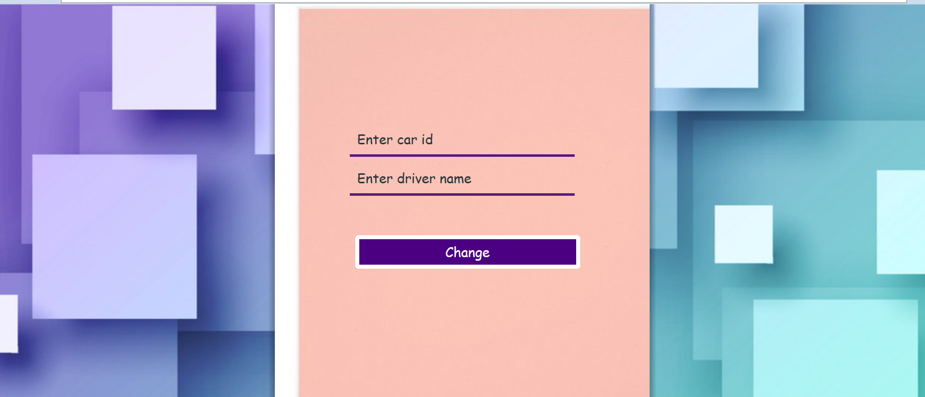

Code:

<!DOCTYPE html><html><head><meta charset=*"ISO-8859-1"*>

<title>carupdate</title>

<link rel=*"stylesheet"* type=*"text/css"* href=*"adddcar.css"*></head>

<body>

<div class=*"Box"*>

<form action=*"./carupdate"* name=*"frm"* method=*"post"*>

<div class=*"login-box"*><br><br><br><br><br><br><br><br>

<center>

<div class=*"textbox"*>

<input type=*"text"* placeholder=*"Enter car id"* maxlength=*"6"* id=*"user"* name=*"t1"* value=*""*required=*"required"*>

</div>

<div class=*"textbox"*>

<input type=*"text"* placeholder=*"Enter driver name"* id=*"pass"* name=*"t2"* value=*""* required=*"required"*></div><br><br>&nbsp;&nbsp;&nbsp;

<button type=*"submit"* id=*"sub"* >Change</button><br><br><br><br><br><br><br><br><br><br>

</center></div></form></div></body></html>

**Admin viewfeedback**

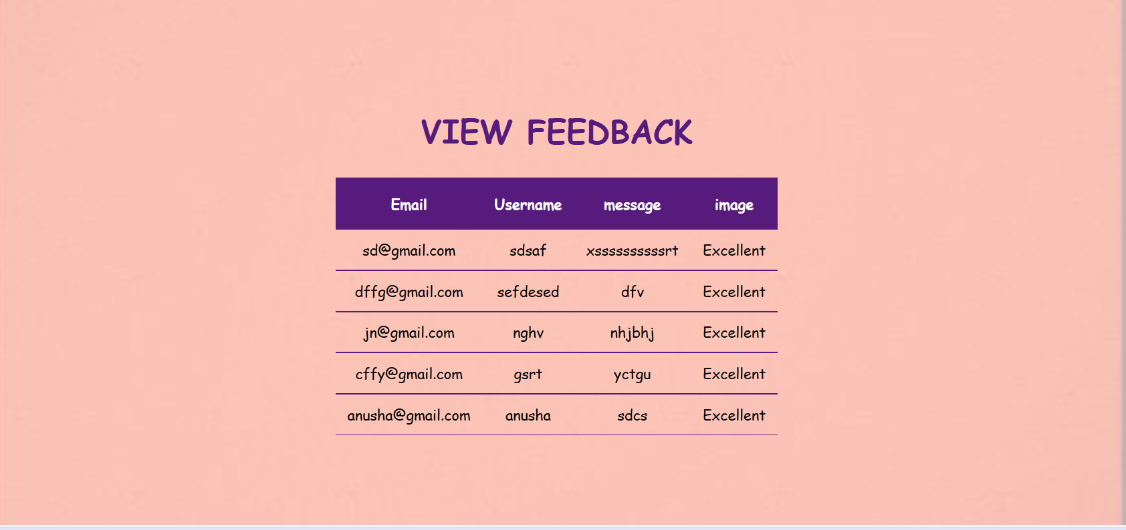

Code:

<%@ page language=*"java"* contentType=*"text/html; charset=ISO-8859-1"* pageEncoding=*"ISO-8859-1"*%>

<%@page import=*"java.sql.*"*%> [%@page import=*"java.sql.DriverManager"*%](mailto:%25@page%20import=%22java.sql.DriverManager%22%25)

<%@page import=*"java.sql.ResultSet"*%><%@page import=*"java.sql.Statement"*%>

<%@page import=*"java.sql.Connection"*%>

<!DOCTYPE html><html><head><meta charset=*"ISO-8859-1"*>

<title>Insert title here</title>

<link rel=*"stylesheet"* type=*"text/css"* href=*"adminview.css"*></head>

<body> <br><br><br><br>

<div class=*"table-responsive"*>

<center><h1>VIEW FEEDBACK</h1></center></div>

<table class=*"content-table"* align=*"center"*>

<thead>

<tr><th>Email</th><th> Username</th><th> message</th><th>image </th></tr>

<thead><tbody>

<%

**try**{

Class.forName("com.mysql.jdbc.Driver");

Connection conn=DriverManager.getConnection("jdbc:mysql://localhost:3306/sushma1","root","root");

String Query ="select * from feedback";

Statement stm =conn.createStatement();

ResultSet rs=stm.executeQuery(Query);

**while**(rs.next()){

%>

<tr>

<td><%=rs.getString("Email")%></td>

<td><%=rs.getString("Username") %></td>

<td><%=rs.getString("message") %> </td>

<td><%=rs.getString("image") %> </td>

</tr>

<%

}}

**catch**(Exception ex)

{

out.println("Exception:" +ex.getMessage());

ex.printStackTrace();

}

%>

</tbody></table></body></html>